Using Standardized Patients to   
Measure Health Care Quality  
**A Manual and Toolkit For Projects in Low- and Middle-Income Countries**

***ANNEXES***

Ada Kwan, Sofi Bergkvist, Benjamin Daniels

*with* Jishnu Das, Veena Das, and Madhukar Pai

*Version 5*

*Last updated on April 23, 2018*

*Updated versions of the manual and annexes can be accessed at:*

*https://www.qutubproject.org/*

Macintosh HD:Users:adakwan:Dropbox:TB QUALITY INDIA 2014:-1000 - RESULTS DISSEMINATION:2014 Delhi research packet:CC-BY_NC 88x31.png QUTUB PROJECT, APRIL 2018

|  |
| --- |
| *To use this material as a whole, or in part, please cite the corresponding manual as well as the references listed at the beginning of each annex. The manual can be cited as:*  **Kwan A, Bergkvist S, Daniels B, Das J, Das V, Pai M. Using Standardized Patients to Measure Health Care Quality: A Manual and Toolkit for Projects in Low- and Middle-Income Countries. 2018.** |

All content in this document unless otherwise noted is licensed under the Creative Commons Attribution-NonCommercial 4.0 International License. To view a copy of this license, visit http://creativecommons.org/licenses/by-nc/4.0/ or send a letter to Creative Commons, PO Box 1866, Mountain View, CA 94042, USA.

Table of Contents

Annex A. Sample budget & justification templates (Section 3.1) 4

Annex B. Description of SP method for IRB submission (Section 5.2) 10

Annex C. Template for provider consent form (Section 5.2) 13

Annex D. Template letter of full disclosure at study completion in lieu of consent (Section 5.2) 16

Annex E. Ethical considerations for SP study (Section 5.2) 18

Annex F. Study authorization letter template for National Government (Section 5.5) 23

Annex G. Study authorization letter template for Local Government (Section 5.5) 26

Annex H. Health screening questionnaire for potential SPs (Section 5.8) 28

Annex I. SP confidentiality agreement template (Sections 5.9, 8.5) 36

Annex J. SP script – sample from Qutub Project (Section 6.2) 38

Annex K. SP exit questionnaire – sample from Qutub Project (Sections 6.2, 6.5) 45

Annex L. Follow-up detection survey and vignette – sample from Qutub Project (Sections 6.6, 6.7) 55

Annex M. 3-week SP training schedule 75

Annex N. Supervisor fieldwork schedule – Example (Section 9.2) 77

Annex O. SP fieldwork schedule – Example (Section 9.2) 80

Annex P. SP comments – Edited (Section 10.4) 82

Annex Q. SP data files (Section 11) 86

Annex Q1. SP data files – Provider universe master code example (Section 11.1) 87

Annex Q2. SP data files – Sample master code file example (Section 11.1) 87

Annex Q3. SP data files – Schedule master code file example (Section 11.1) 87

Annex Q4. SP data files – SP staff master code file example (Section 11.1) 88

Annex Q5. SP data files – Medicines master code file example (Section 11.1) 89

Annex Q6. SP data files – Exit questionnaire master data dictionary file example (Section 11.3) 89

# Annex A. Sample budget & justification templates (Section 3.1)

|  |
| --- |
| ***To use this annex as a whole, or in part, please cite:***   * **Kwan A, Bergkvist S, Daniels B, Das J, Das V, Pai M. Using Standardized Patients to Measure Health Care Quality: A Manual and Toolkit for Projects in Low- and Middle-Income Countries. 2018.** * **Das J, Kwan A, Daniels B, Satyanarayana S, Subbaraman R, Bergkvist S, Das RK, Das V, Pai M. Use of standardised patients to assess quality of tuberculosis care: a pilot, cross-sectional study. The Lancet Infectious Diseases. 2015 Nov 30;15(11):1305-13.** |

**A1. Sample budget templates**

|  |  |  |  |  |
| --- | --- | --- | --- | --- |
| ***Research Team*** | **Amount per day/person** | **Number of people** | **Number of days** | ***Total*** |
| Principal investigators |  |  |  |  |
| International project manager/director and analyst |  |  |  |  |
| Post-doctoral fellows |  |  |  |  |
| Research assistants |  |  |  |  |
| Consultants |  |  |  |  |
|  |  |  |  |  |
| ***Technical Working Group*** | **Amount per day/person** | **Number of people** | **Number of days** | ***Total*** |
| Meeting venue |  |  |  |  |
| Travel expenditures |  |  |  |  |
| Food and snack during meetings |  |  |  |  |
|  |  |  |  |  |
| ***SP Training*** | **Amount per day/person** | **Number of people** | **Number of days** | ***Total*** |
| SP/Supervisor (Junior/Senior) per diem during training |  |  |  |  |
| Training location and lunch |  |  |  |  |
| Training supplies |  |  |  |  |
| Transportation to training for field staff |  |  |  |  |
| Accommodation for field staff |  |  |  |  |
| Postings and advertisements for recruitment |  |  |  |  |
|  |  |  |  |  |
| ***Data Collection Period*** | **Amount per month/person** | **Number of people** | **Number of months** | ***Total*** |
| Provider fees (consultations, tests, medicines) |  |  |  |  |
| Communication costs |  |  |  |  |
| Supplies |  |  |  |  |
| General transportation costs |  |  |  |  |
|  |  |  |  |  |
| Standardized Patient salary |  |  |  |  |
| Standardized Patient transport |  |  |  |  |
| Standardized Patient food allowance |  |  |  |  |
| Standardized Patient communication |  |  |  |  |
| Standardized Patient out of home accommodation |  |  |  |  |
|  |  |  |  |  |
| Local project manager salary |  |  |  |  |
| Jr. Supervisor salary |  |  |  |  |
| Jr. Supervisor transport allowance |  |  |  |  |
| Jr. Supervisor food allowance |  |  |  |  |
| Jr. Supervisor communication |  |  |  |  |
| Jr. Supervisor out of home accommodation |  |  |  |  |
|  |  |  |  |  |
| Sr. Supervisor salary |  |  |  |  |
| Sr. Supervisor transport allowance |  |  |  |  |
| Sr. Supervisor food allowance |  |  |  |  |
| Sr. Supervisor communication |  |  |  |  |
| Sr. Supervisor out of home accommodation |  |  |  |  |
|  |  |  |  |  |
| ***Medication Coding*** | **Amount per month/person** | **Number of people** | **Number of months** | ***Total*** |
| Auditor salary |  |  |  |  |
| Auditor transport allowance |  |  |  |  |
| Auditor food allowance |  |  |  |  |
| Auditor communication |  |  |  |  |
| Auditor accommodation |  |  |  |  |
|  |  |  |  |  |
| ***Data Management*** |  |  |  |  |
| Data Entry Software Design |  |  |  |  |
| Data Entry cost |  |  |  |  |
| Data Entry Survey Cabinet |  |  |  |  |
| Survey Storage for 5 years |  |  |  |  |
| Survey Printing |  |  |  |  |
|  |  |  |  |  |
| ***Computer Assisted Interviewing*** |  |  |  |  |
| Survey Software License |  |  |  |  |
| Survey Programming |  |  |  |  |
|  |  |  |  |  |
| ***Translation*** |  |  |  |  |
| Translation of the survey |  |  |  |  |
| Translation of qualitative responses of exit questionnaires |  |  |  |  |
| ***Other expenditures to consider*** |  |  |  |  |
| Technical advisory meeting costs |  |  |  |  |
| Permits needed for the study |  |  |  |  |
| Insurance of personnel |  |  |  |  |
| Miscellaneous (communication, supplies) |  |  |  |  |

**A2. Budget justification template for a 3-year SP study**

|  |  |
| --- | --- |
| ***A. Personnel and Fringe Benefits (Direct FTE Costs)*** | |
| International Project Manager/Director and Data Analyst | Role: The international PM/analyst will be responsible for coordinating across the SP field team, relevant health institutions, implementing agencies and other medical institutions, and consultants required to successfully complete the project. Along with the PIs, the international PM/analyst will be responsible for producing documentation on the SPs, achieving consensus among stakeholders and responding to specific issues that arise in the deployment of SPs and the interpretation of the data. For the successful completion of the project, the international PM/analyst will work with the PIs and stakeholders to obtain relevant permissions for the study, such as ethics review board approvals and national or local permissions. The international PM/analyst will be responsible for identifying and working with the survey programming and data entry team to ensure high quality data management from the data collection to data analysis stages, as well as working with pharmacists to determine the type and quality of drugs that are prescribed or dispensed during the SP interactions. Finally, the international PM / analyst will work with the PIs to produce timely reports, briefs and short papers for publication.  Salary: [#]% of time in year 1, and [#]% of time for years 2 and 3, based on an annual salary of $[SALARY].  Fringe: [#]%, which includes health insurance, pension contributions and other benefits. |
| Post-doctoral Fellow | Role: The Postdoctoral Fellow will handle all the sampling, compilation and statistical analysis of the data. The Postdoctoral Fellow will be based in [CITY, UNIVERSITY] with [#] trips every year to [STUDY SETTING] to work with the implementing partners and data entry team. The fellow will first work on the pilot data entry and report production design with the data team that is identified. The fellow will then complete the sampling, accounting for seasonality and random cross-matching of SPs to sampled providers. Finally, the fellow will regularly oversee the data collection, compile the data for dissemination and analyze the data for reports and publications.  Stipend: [#]% of time for the first 2 years and [#]% of time for year 3, based on an annual stipend of $[STIPEND].  Fringe: None. |
| Local Project Manager | Role: The local project manager will be responsible for the day-to-day supervision of field, data collection, and implementation activities and will be based in [STUDY SETTING]. The local PM is expected to travel frequently to all field sites, and work with the international PM, implementing partners and the PIs on any issues that arise in the field. The local PM will also coordinate among various bodies to ensure smooth implementation of the surveillance system.  Salary: [#]% of time in year 1, and [#]% of time for years 2 and 3, based on an annual salary of $[SALARY].  Fringe: None. |
| ***B. Direct Travel*** | |
| Trips to [STUDY SETTING] | Purpose: The funds will cover [#] trips to [STUDY SETTING] for the Post-doctoral Fellow, [#] trips to [STUDY SETTING] for the International PM, [#] trips each for the PIs. In year 1, the Fellow will conduct [#] visits for provider sampling; the Fellow or International PM, and the PIs will each travel to work with the SP field team during SP training, and to [STUDY SETTING] during the first year of the survey. In year 2, similar visits will take place. In year 3, the Fellow or International PM, and the PIs will travel to [STUDY SETTING] for the second year of the survey.  Number: [TOTAL NUMBER OF TRIPS]  Duration: Variable, depending on the needs of the project/person traveling.  Included: Flight (and internal flight, if applicable), lodging, local transportation and incidentals.  Cost: [TOTAL COSTS WITH AVERAGE TRIP COST] |
| In-person coordinating meetings | Purpose: Overall coordination of the project will be done through teleconferences. However, for project discussions and decisions that are more difficult or impossible to discuss/resolve over the phone, the PIs will meet in [CITIES] [#] a year in order to discuss progress, share information/data, troubleshoot project issues and hold meetings with various members of the other team on-site. These meetings will be especially crucial at the end of year 1 and at the end of year 2.  Number: Total of [#] trips.  Duration: Approximately [#] days per trip.  Included: Flight, lodging, local transportation and incidentals.  Cost: [TOTAL COSTS WITH AVERAGE TRIP COST] |
| Conferences | Purpose: We have budgeted for [#] conferences to present findings and encourage results dissemination. In order to estimate the cost, average cost per conference is imputed from the most recent [CONFERENCE OF INTEREST] in [CONFERENCE YEAR] at [CONFERENCE LOCATION].  Number: Total of [#] conferences, [#] participants  Duration: Approximately [#] days per trip.  Included: Conference registration, flight, lodging, local transportation and incidentals.  Cost: [TOTAL COSTS WITH AVERAGE TRIP COST] |
| ***C. Direct Consulting*** | |
|  | |
| ***D. Direct Supplies and Other (<10k)*** | |
| Provisions have been made to pay for baseline and endline data-entry, at a total cost of $10,000. | |
| ***E. Direct Equipment (>10k)*** | |
| During the development of SP scenarios, the team will work with [DATA FIRM] to design the data-entry and data systems that will support the project’s analysis and results dissemination goals. An interactive web-based (password protected) query-based system will be designed. This system will allow the research team and stakeholders to access data with specific permissions and as required. The system will also generate a number of reports based on data. The form of the reports will be decided prior to the completion of the system with the relevant stakeholders. The budget for devising this system is $[TOTAL COST]. | |
| ***F. Sub-Grants and Subcontracts (Sub-Awards)*** | |
| [SP FIELD TEAM FIRM NAME]  The bulk of the project costs are for the implementation of the SP work, which includes SP visits with sampled providers, data entry, and completion of additional surveys. There are a total of [#] SP case scenarios in this project. The subcontracted firm will train [#] SPs for each case scenario, and will keep [#] SPs "in reserve", in case regular SPs should leave, for a total of [#] SPs for the entire study. With an estimated [#] providers in the sample, the total number of interactions will be [#] interactions. SPs will cost around $[MONTHLY COST] per month, including salary and travel per diems. Therefore, the total cost for SPs per year comes to $[YEARLY COST], with a total of $[TOTAL COST] for the duration of the project ([#] years). In addition, $[TOTAL COST] is budgeted for SP training. The firm contracted as the field team will also deploy [#] senior supervisors, whose costs of time and travel will be $[YEARLY COST] per year for a total of $[YEARLY COST] and [#] junior supervisors at $[YEARLY COST] per year for a total of $[YEARLY COST]. In addition, $[YEARLY COST] per year (total of $[TOTAL COST]) has been set aside as contingency funds for unexpected expenses. | |
| ***G. Other Sources of Support for This Project*** | |
| [INVESTIGATOR]’s time and effort for this project will not be charged to this grant, and will be provided in-kind. This represents [#]% of time and effort, based on an annual salary of $[SALARY], plus [#]% of benefits, for the duration of the project, i.e. a total of $[TOTAL COST]. | |
| ***H. Other Related Funded Projects*** | |
| **Other funds related to the project include the following.**  **Grantor/Title of Project Funded:**  **Amount Funded in USD:**  **Description of Related Funding:** | |

# Annex B. Description of SP method for IRB submission (Section 5.2)

Source: Qutub Project, urban India

PIs: Madhukar Pai, Jishnu Das

Project period: September 2014 – ongoing

|  |
| --- |
| ***To use this annex as a whole, or in part, please cite:***   * **Kwan A, Bergkvist S, Daniels B, Das J, Das V, Pai M. Using Standardized Patients to Measure Health Care Quality: A Manual and Toolkit for Projects in Low- and Middle-Income Countries. 2018.** * **Das J, Kwan A, Daniels B, Satyanarayana S, Subbaraman R, Bergkvist S, Das RK, Das V, Pai M. Use of standardised patients to assess quality of tuberculosis care: a pilot, cross-sectional study. The Lancet Infectious Diseases. 2015 Nov 30;15(11):1305-13.** |

|  |  |  |  |  |  |  |  |  |  |  |  |  |  |  |  |  |  |  |  |  |  |  |  |  |  |  |  |  |  |  |  |  |  |  |  |
| --- | --- | --- | --- | --- | --- | --- | --- | --- | --- | --- | --- | --- | --- | --- | --- | --- | --- | --- | --- | --- | --- | --- | --- | --- | --- | --- | --- | --- | --- | --- | --- | --- | --- | --- | --- |
| Use of Standardized Patients and Other Approaches to Measurement of Quality  A variety of different methods are available to measure quality of care. The table below summarizes different quality measures by assessing (A) the extent to which they measure knowledge versus practice; (B) the extent to which they are able to provide estimates that account for confounders; and (C) the extent to which they are able to provide information on a broad set of illnesses, highlighting the advantages and disadvantages of different measures (Source: MAQARI. Standardized patients and the measurement of healthcare quality. Field guide, manual, and sample instruments).   |  |  |  |  |  |  |  | | --- | --- | --- | --- | --- | --- | --- | | **Measure of Quality** | **Measures Knowledge** | **Measures Practice** | **Accounts for Case-Mix** | **Accounts for Patient-Mix** | **Hawthorne Effects (doctors may change their behavior because of the study)** | **Illnesses Covered** | | Vignettes | Yes | No | Yes | Yes | Yes | All | | Clinical Observation | No | Yes | No | No | Yes | Limited in two ways. First, “serious” illnesses like unstable angina will show up on a sporadic basis. Second, the observer never knows what the patient actually has—and doctors frequently make incorrect diagnoses. | | Chart Abstraction | No | Yes | No | No | No | Similar to clinical observation, but providers rarely keep patient charts. Even when they exist, charts tend to be incomplete and don’t accurately reflect patient-provider interactions. | | Standardized Patients | No | Yes | Yes | Yes | No | Limited to (A) adults only; (B) diseases that don’t have any obvious physiological symptoms (which cannot be mimicked) and (C) conditions that don’t require invasive exams—particularly in low-income countries. |   While the vignettes and provider observation methods generate insight into specific components of the quality of care available, these methods have significant limitations.1,2 Vignettes provide an accurate picture of provider knowledge for a wide range of illnesses and can control for case and patient-mix, but they do not reflect clinical practice, as a large know-do gap has been documented in a variety of settings.1,2,3,4  Direct clinical observation can provide information about clinical practice, but this method is limited in four ways. First, observed differences in quality may be confounded with differences in patients and illnesses presented. Although it is possible to control for case and patient mix using vignettes, observed measures of what happens in practice are subject to the usual confounders of severity and patient characteristics. Second, because the majority of patients on any given day present with self-limiting or “minor” illnesses, it is very difficult to assess process-quality for patients with severe or life-threatening illnesses. It is likely that several weeks of observation would be required before a TB patient is observed in the practice of a regular provider. Third, since it is often not possible – due to ethical reasons – to have medically trained doctors as observers, it is difficult to assess whether the illness that the patient presented with or the course of treatment prescribed or administered by the providers were indeed correct. For instance, if a patient does present with 3 weeks of cough, it will be impossible for the (medically untrained) observer to evaluate whether the patient was genuinely suffering from TB. Finally, the presence of an observer in the clinic may itself change the provider’s behavior (i.e. the “Hawthorne effect”).3,4  While we plan to triage the quality of care using these different methods, the main indicator of the quality of practice will be based on the use of SPs. Formally, a standardized patient is an individual who is extensively coached to portray the historical, physical and emotional features of an actual patient accurately and in a standardized, consistent manner. They come from all walks of life and need to be emotionally mature, affable, and intelligent and have flexible schedules (for assignments are rarely regularly scheduled).  There are two components of the SP: standardization and simulation. The objective of standardization is to present a case in a clinically accurate and consistent manner while the objective of simulation is to imitate the natural environment in which clinical encounters happen in any given social context. The goal is to “pass” as a normal patient without being detected by the medical service provider. All the SPs portraying a particular scenario are meticulously trained and rehearsed to ensure that the clinical presentation as well as the emotional, physical and psychosocial aspects of the patient they represent — speech, body language, dress, reactions to physical examinations — are standardized thus ensuring that each provider, when meeting an SP, will face the same clinical challenge. An ideal SP can also be coached to accurately recall details of his or her encounter with the healthcare providers, thus providing an opportunity to generate data on quality of care (e.g. to what degree a task is done or not done, whether or not a question is asked) and to provide feedback about the process.  The SP methodology thus presents an opportunity to control the case mix and the patient presentation, enabling us to obtain a measure of quality (e.g. case detection rate) that is comparable across all providers. It also provides a measure of clinical quality uncontaminated by Hawthorne effects and recall bias. Compared to provider observation and vignettes, the use of SPs should give a more “real-world”, and presumably more accurate, portrayal of a doctor’s effort and expertise. Because vignettes measure the frontier of what the provider can do for a given case, they are relatively good at capturing errors of commission (where the provider does what is clinically inappropriate, possibly due to knowledge-related incompetence) but not as good at capturing errors of omission (where the provider fails to do what is clinically appropriate and essential, although he or she may have the appropriate knowledge). With the appropriate design of clinical cases and carefully trained SPs, it should be possible to detect both errors of omission and commission. For all these reasons, SPs are considered to be the ‘gold standard’ method of assessing provider communication skills and behavior.  However, SP-based studies also have their limitations. Perhaps the most restricting concern the kinds of cases that can be used in low-income countries. Due to ethical concerns, case presentations by a child are by necessity eliminated, as are those that require invasive examinations. Although invasive examinations do not preclude the use of SPs in medical education in high-income countries, in typical clinics in low-income countries, any kind of invasive examination (including the use of a thermometer) or treatment (e.g. injections) can result in a health-risk to the SP. In addition, SP-based cases are also necessarily limited to those with no clear and highly visible symptoms. However, this does not necessarily limit cases where the symptoms become noticeable only after further testing, as the quality of the provider can be ascertained based on whether the correct tests were prescribed.  Standardized patients have been used extensively in Canada in medical education settings (e.g. clinical skills and licensure exams), and in research studies aimed at improving quality of care. SPs have also been used within McGill-affiliated and MUHC hospitals for this purpose.5,6  **References**   1. Das J, Hammer J. Money for nothing: The dire straits of medical practice in Delhi, India. J Development Economics 2007;83:1-36. 2. Das J, Hammer J, Leonard K. The Quality of Medical Advice in Low-Income Countries. Journal of Economic Perspectives 2008;22:93-114. 3. Leonard K, Masatu MC. Outpatient process quality evaluation and the Hawthorne Effect. Soc Sci Med 2006;63:2330-40. 4. Leonard KL, Masatu MC. The use of direct clinician observation and vignettes for health services quality evaluation in developing countries. Soc Sci Med 2005;61:1944-51. 5. Tamblyn R, Berkson L, Dauphinee WD, et al. Unnecessary prescribing of NSAIDs and the management of NSAID-related gastropathy in medical practice. Ann Intern Med 1997;127:429-38. 6. Tamblyn RM. Use of standardized patients in the assessment of medical practice. CMAJ : Canadian Medical Association journal = journal de l'Association medicale canadienne 1998;158:205-7. |

# Annex C. Template for provider consent form (Section 5.2)

Source: KePSIE project, Kenya

Principal Investigators: Jishnu Das, Guadalupe Bedoya

Project period: 2015 – ongoing

|  |
| --- |
| ***To use this annex as a whole, or in part, please cite:***   * **Kwan A, Bergkvist S, Daniels B, Das J, Das V, Pai M. Using Standardized Patients to Measure Health Care Quality: A Manual and Toolkit for Projects in Low- and Middle-Income Countries. 2018.** * **Daniels B, Dolinger A, Bedoya G, Rogo K, Goicoechea A, Coarasa J, Wafula F, Mwaura N, Kimeu R, Das J. Use of standardised patients to assess quality of healthcare in Nairobi, Kenya: a pilot, cross-sectional study with international comparisons. BMJ global health. 2017 Jun 1;2(2):e000333.** |

|  |
| --- |
| Request For Participation & Informed Consent Form  Title: [Project name]  Principal Investigators: [Names]  [Institution, Location]  In Collaboration with [Name of collaborators]    Sponsors: [Sponsor names]  INTRODUCTION AND PURPOSE OF THE PROJECT  You are being asked to participate in a study designed to understand what goes on when a doctor is treating a patient who may have one of a set of identified common illnesses. Results from this study will be used [*insert study purpose, such as* “to improve our study instruments and methodology before we conduct a big scale version of the study”]. Carefully read the consent form, and do not hesitate to ask questions. If you decide to participate, we will ask you to sign the form, and you will be given a copy. People who take part in such research projects do it voluntarily, and have to give their written consent. Your participation in this study is strictly voluntary. You may refuse to participate or discontinue your participation at any time without explanation, and without any prejudice.  **PATIENT VISIT AND FOLLOW-UP**  If you agree to participate, the coordinator will assign you a Study ID. In the following 6 months, you will be visited by someone who has been trained by us to act as a patient. These patients are called “standardized patients” and this approach has been used to assess quality of medical care. You will not know exactly when this standardized patient will visit you, but please note the date and time if/when you think you saw this standardized patient. No later than one month after this visit, our research team will contact you to find out if/when you saw our standardized patient.  POTENTIAL BENEFITS, RISKS AND/OR DISCOMFORTS  You will not directly benefit from taking part in this study, and there are no risks to you from this study. The standardized patient who visits you for a consultation will pay your usual consultation fees. So, you will not suffer any economic loss due to participation in this study. While you will not directly benefit from the research, we hope that the information from this study will help us understand how the standardized patient approach can be used to better understand quality of care in [location]. We hope our research will help with this goal.  CONFIDENTIALITY  [*Insert the following if proceeding with audio recording,* “With your permission, we would like to audiotape the standardized patient visit.”] All the information collected will be kept strictly confidential by identifying you with a unique code (or study ID) to which only authorized personnel will have access. The results from this study may be published, but your identity will never be revealed. Your name, coordinates, the start and end date of participation in the project, as well as audio recordings, will be stored for five (5) years after the study is over in a separate registry maintained by the investigators. In order to verify the research study data, monitors from the [Name of ethics committee(s) that provided clearance to this project] may review these records.  ETHICAL ASPECTS OF THE STUDY  The ethics committee of [Name of ethics committee(s)] have reviewed and approved this study and ensure the follow-up. They will also approve any changes made to the information/consent form and to the study procedure. In addition, [Name of ethics committee(s)] can make visits to study sites in order to ensure their quality.  QUESTIONS  If you have questions about your rights as a research subject or regarding any damage attributable to the research and wish to discuss this with someone not involved in the study, you may contact:  [Location or Area]: [Contact details]  Declaration of Consent  Title: [Project name]  Principal Investigators: [Names]  [Institution, Location]  In Collaboration with [Name of collaborators]    Sponsors: [Sponsor names]  I have read the content of this consent form, and I agree to participate in this research study. I have had the opportunity to ask questions and all my questions have been answered to my satisfaction. I have been given sufficient time to consider the above information and to seek advice if I choose to do so. I will be given a copy of this signed consent form. By signing the consent form, I have not given up any of my legal rights.  **participant**  YES NO  I consent to take part in this survey 🞏 🞏  \_\_\_\_\_\_\_\_\_\_\_\_\_\_\_\_\_\_\_\_\_\_\_\_\_\_ \_\_\_\_\_\_\_\_\_\_\_\_\_\_\_\_\_\_\_\_\_\_\_\_\_\_\_  Signature of the participant Name (in block letters) Date  **project coordinator**  I confirm having met with the participant at the time of enrolment to answer questions about this study.  \_\_\_\_\_\_\_\_\_\_\_\_\_\_\_\_\_\_\_\_\_\_\_\_\_\_ \_\_\_\_\_\_\_\_\_\_\_\_\_\_\_\_\_\_\_\_\_\_\_\_\_\_\_  Signature of the person Name (in block letters) Date  administering the informed  consent |

# Annex D. Template letter of full disclosure at study completion in lieu of consent (Section 5.2)

Source: Qutub project, urban India

Principal Investigators: Madhukar Pai, Jishnu Das

Project period: September 2014 – ongoing

|  |
| --- |
| ***To use this annex as a whole, or in part, please cite:***   * **Kwan A, Bergkvist S, Daniels B, Das J, Das V, Pai M. Using Standardized Patients to Measure Health Care Quality: A Manual and Toolkit for Projects in Low- and Middle-Income Countries. 2018.** * **Das J, Kwan A, Daniels B, Satyanarayana S, Subbaraman R, Bergkvist S, Das RK, Das V, Pai M. Use of standardised patients to assess quality of tuberculosis care: a pilot, cross-sectional study. The Lancet Infectious Diseases. 2015 Nov 30;15(11):1305-13.** |

|  |
| --- |
| Dear [Provider]:  We are a research team from [institution name (location)].  Over the last [time period], we have been working closely with [relevant organizations and agencies] to understand [research goals]. This is an important issue because [study rationale].  As part of this initiative, we selected providers by [method of sample selection]. These providers were from [study location(s)], and they received standardized patients over [time period of the study].  Standardized patients are regularly used in medical education and are people trained to present symptoms of a disease in a clinical interaction and to answer any questions asked by the provider. The standardized patients we sent to [study sample] presented with certain symptoms to these clinics. With permission from our research institution, all patients were unannounced which allowed us to record the nature of care being provided with validity. The identities of these clinics and providers will not be given to anyone, since our interest is in general patterns across [location] and not in the performance of any individual clinics located in our sample. [This initiative was started after first piloting the approach and checking with a large number of doctors and health care providers that there were no adverse effects on the initiative on their practices.]  We are able to provide general feedback on the results of our study, aggregated at the [level of analysis]. We are eager to hear your opinions about this study and its outcomes. We would also like to be able to discuss with you the relevance of the methods we used and ask your frank opinion about the use of unannounced patients. You are under no compulsion to discuss these findings or issues arising from our study, but if you would like to discuss these issues with us we would be happy to schedule a meeting at your convenience.  If you are interested in hearing more results about this project or would like further information, please contact us through email at [email contact] or through phone at [phone contact] and we will fix a time and place for a member of our team to visit you. Following the discussion with the member of our team, if you have further concerns, we will put you in contact with the [ethics committee] at [institution name].  Lastly, regardless of whether you wish to contact us for further discussion or not, we want to express our grateful thanks for your contribution to our project and for the work you are doing among the population in [location].  Sincerely,  [Principal Investigators]  [Titles] |

# Annex E. Ethical considerations for SP study (Section 5.2)

Source: Qutub project, urban India

Principal Investigators: Madhukar Pai, Jishnu Das

|  |
| --- |
| ***To use this annex as a whole, or in part, please cite:***   * **Kwan A, Bergkvist S, Daniels B, Das J, Das V, Pai M. Using Standardized Patients to Measure Health Care Quality: A Manual and Toolkit for Projects in Low- and Middle-Income Countries. 2018.** * **Das J, Kwan A, Daniels B, Satyanarayana S, Subbaraman R, Bergkvist S, Das RK, Das V, Pai M. Use of standardised patients to assess quality of tuberculosis care: a pilot, cross-sectional study. The Lancet Infectious Diseases. 2015 Nov 30;15(11):1305-13.** |

|  |
| --- |
| ETHICAL CONSIDERATIONS   * 1. Ethics Approvals   This study will be conducted according to ethical principles stated in the Declaration of Helsinki (2008). We will submit our research proposal to the research ethics committee(s) at the McGill University Health Centre (MUHC) to obtain ethics approval prior to initiating the project. Institute of Socio-Economic Research on Development and Democracy (ISERDD), our partner site in India will also seek and obtain the necessary ethics approval.   * 1. Informed Consent – Waiver   With this submission, we are seeking approval for the main project, for which we are requesting a waiver for provider informed consent. On the governmental level, our project is explicitly included in the Memorandum of Understanding (MoU) between the Gates Foundation and the Municipal Corporation of Greater Mumbai (MCGM) [see Additional Documentation], and with a MoU between the Bihar State Government and the Gates Foundation for TB interventions. In addition, we will require the Foundation’s support to get explicit approvals from both local governments for sampling providers from the public sector. With this and taking into account previous studies involving the SP method for which informed consent has been waived (described below), we believe that demonstrating a scientifically valid answer to our research questions is not possible unless the requirement of individual provider informed consent is waived.  Previous SP studies conducted by Dr. Das and colleagues from our team have requested and received waivers of informed consent from ethics committees at Harvard University, Duke University, and through the partner institution of the study presented here, ISERDD. We will share the IRB protocols and approvals, if requested, of this precedent. Another SP study conducted at the Universidad Peruana Cayetano Heredia has also received waiver of informed consent.1  These waivers have been granted under the provisions for waiver or alteration of the informed consent requirements under the United States Department of Health and Human Services regulations 45 CFR 46.116(d) (Office for Human Research Protections (OHRP). Accessed at: <http://www.hhs.gov/ohrp/policy/consentckls.html>).  This research will involve no more than minimal risk to participants. We have documented in our pilot study that our project is minimally intrusive with no risks or harms to the providers participating in the project, and in the next section, we discuss the maintenance of strict confidentiality of our research data involving several mechanisms to protect confidentiality of participating healthcare providers in the study. In our detection survey, we elicited provider opinions on whether participation in the study had adversely affected their practice in any way. The results are stark: of the 98 responding providers, not a single one replied with the affirmative. From the point of view that sending SPs to providers can be harmful, the view of the participants of our pilot unanimously demonstrates that it does not.  The lack of participant consent is unlikely to adversely affect the welfare of the participants. Based on our pilot study, we predict that the lack of the participant’s consent is unlikely to adversely affect the welfare of the providers for several reasons. Firstly, no financial losses will be incurred by providers as the SPs, like real patients, will pay them whatever they charge in the clinics. There will be no added inconvenience to other patients as we will train the SPs on how to immediately step aside if there is an emergency that demands the doctor’s attention. From our observations, average consultation times are between 3 and 7 minutes, so this will only inconvenience other patients only by that time. None of the identities of the providers or their health facilities will be compromised since we will maintain strict anonymity in the information collected. At no time during or after the project (or in any publications or presentations) will the providers or health facilities be identified.  Additionally, the ethics guidelines on health services audit studies state that SPs should be used in cases where the person being sent the SP is providing a service to other people and where other options have been carefully studied, but cannot answer the research questions required. For our study, we have made the educated decision to select the SP approach after more than a decade of research, during which we were unable to find adequate ways to answer the research questions about quality of health care that can be answered by using SPs. For example, with the direct observation approach, four notable issues arise:   1. How can the true condition of the client be determined? In this case, research teams are not able to determine the actual percentage of people with three weeks cough asked to do a sputum test when there is no way to determine whether the person really has tuberculosis or not. 2. A real tuberculosis patient is a rare even and will appear very infrequently in a clinic. 3. What is a trained team to observe quality of care to do if the observed doctor begins to engage in malpractice? 4. Direct observation is limited by the Hawthorne effect, which suggests that when observed while doing a job or task, individuals will have the propensity to alter their natural routine.   In short, there is no other way to get at illness-specific metrics of care, or at least none that unequivocally presented any issues. Also, after the pilot in Delhi and based on the pilot’s detection results, we do not recommend any changes to the SP practice implemented and believe that the combination of greater spacing of SPs and the waiver of informed consent will bring detection rates to below 1-2 percent. Additionally, our particular study, which will evaluate the quality of care among networked providers who will attend many trainings and workshops together, confronts an added risk of the PPIA networked providers discussing the identities and personal characteristics of the SPs throughout the two-year period of the study during which we will send SPs multiple times as surveillance monitoring for two-month periods for a total of four months in each city of Mumbai and Patna, India. The combination of informed consent and congregation of providers at frequent intervention trainings (at times several are scheduled in one week) threaten the validity of our study as reported responses would not reflect the actual quality of care we are aiming to measure and the risk of SP detection may increase.  We want to emphasize that this research does not involve any therapeutic interventions or other clinical or diagnostic interventions. As part of their training, SPs are fully informed and trained on how to recognize and avoid harmful situations, such as avoiding blood draws and injections. During the pilot in Delhi, we documented 1 adverse event where a standardized patient was injected with a sterile needle. Following the event a full debriefing was conducted, and SPs were led through a refresher on avoiding all invasive examinations. There were no further adverse events noted. The next section discusses this further.  Lastly, we cite a recent study by Rhodes et al. on ethical aspects of simulated patient studies, commissioned by the US Department of Health and Human Services.2 The review found “several relevant considerations both favor and oppose soliciting consent for simulated patient studies. Making research participation conditional on informed consent protects the autonomy of research subjects and shields them from unreasonable exposure to research risks. However, scientific validity is also an important ethical principle of human subjects research, as the net risks to subjects must be justified by the value to society of the knowledge to be gained. The use of simulated patients to monitor access is a naturalistic and scientifically sound experimental design that can answer important policy-relevant questions, with minimal risks to human subjects. As interaction between researchers and subjects increases, however, so does the need for consent.”2  The report concluded: “As long as adequate protections of confidentiality of research data are in place, minimally intrusive simulated patient research that gathers policy-relevant data on the health system without the consent of individuals working in that system can be ethically justified when the risks and burdens to research subjects are minimal and the research has the potential to generate socially valuable knowledge.” 2  In order to fully use the potential of this “mystery client” approach and maximize its impact, SPs have to present themselves as regular patients to health providers, who therefore cannot be informed ahead of time that they will be visited by trained SPs posing as patients. We request that the requirement for provider informed consent be waived to ensure that health providers will treat the SPs as they would any regular patient.  At the end of the study, a letter of full disclosure [*See Annex D*] will be sent to debrief any provider who received an SP. The letter will offer providers a chance to further discuss any aspect of the findings or methodology and register any concerns; however, no individual data on any clinic or provider will be disclosed. Any concerns expressed by providers will be promptly communicated to the IRB.   * 1. Risks to Healthcare Providers   As the pilot study confirmed, there are no obvious risks perceived risk by doctors who will be involved in the study. Doctors will receive their usual consultation fees because standardized patients will be instructed to pay the charges, like any other patient in such settings. So, there is no economic loss for the doctors to participate.  Also, we do not anticipate any risks to the real patients of the healthcare providers for two reasons. First, these are clinics that see on average 15-20 patients a day and the providers spend 3-5 minutes per patient (as shown in our previous SP study in urban and rural India[3](#_ENREF_5), and in our pilot project). Therefore, it is not the case that our study is going to add substantially to the waiting time for any of the patients--we estimate the additional waiting time to be at most 5 minutes. In addition, our protocol also dictates that if there is a medical emergency in the clinic, our SP will immediately step aside.   * 1. Risks to standardized patients   In the previous study in rural India[3](#_ENREF_5), detection rates were less than 1% and one risk was uncovered (providers may try to conduct a tuberculin skin test without asking the SP), and the appropriate risk mitigation measure (SPs must keep their hands below any desk) was designed and implemented during SP training.  In our pilot TB study in India, the detection rate was about 5% of all the SP interactions. We documented 1 adverse event where a standardized patient was given an injection with a disposable, sterile needle. The reason for this violation was that the standardized patient thought that the provider was going to check his blood pressure, when the provider injected him instead. Following the event a full debriefing was conducted and standardized patients were led through a refresher on avoiding all invasive examinations. There were no further adverse events noted.  During each month of data collection, the supervisors will hold two meetings with all the SPs to review the dos and don’ts with regard to SP safety and risk mitigation strategies. During these meetings, supervisors will go over instructions for the SPs on how to avoid invasive or potentially unclean examinations (e.g. thermometers) and interventions (e.g. injections), such as avoiding the placement of their arms on the table and always asking the provider what he intends to do if he moves toward the SP for any examination.  Additionally, there will be a review once a week during which SPs will be asked to describe any situation that arose with regard to invasive procedures and what tactics were used to avoid or refuse such events. SPs will be reminded in these weekly meetings that rather than risk invasive procedures, they should reveal their identities and give the supervisor’s phone number to the provider if they feel that the provider is aggressively pursuing an invasive procedure (we note that this situation did not arise during the pilot in Delhi). Any such a case will be recorded as an adverse event with clear documentation of the circumstances that led to the disclosure.   * 1. Potential benefits   There are no direct benefits for the providers/doctors involved in the study. However, this study will serve to assess the usefulness and impact of the standardized patient strategy to evaluate quality of tuberculosis care, which can in turn inform policy and decision makers, and further the goal of TB control in India. Thus, there is an important public health/societal benefit. Our project will be India’s first-ever larger-scale study of quality of TB care using standardized patients, and if our pilot findings hold true on a larger scale, it can offer valuable insights for intervention and policy.   * 1. Confidentiality   We have documented that our project will maintain strict confidentiality of our research data involving several mechanisms to protect the confidentiality of participating healthcare providers in the study. All study data will be kept confidential. The identity of providers who participate in the study will be anonymized through the process described below. This process will be communicated explicitly to those involved.  During training and throughout data collection, all standardized patients participating in the study are debriefed on their critical duty to restrain themselves from discussing SP and fieldwork experiences with individuals outside of the research team (e.g., family members, friends, neighbors). Standardized patients and supervisors conduct the exit questionnaires and debrief sessions in spaces where they are not to be overheard from others and away from the location of the SP-provider interaction.  All exit questionnaires will be completed on paper, and thus will need to be entered by data entry operators. All data entry operators will sign a confidentiality form stating that they will not discuss or expose any information related to the survey to any person outside the research team. To ensure the confidentiality and the safety of the information gathered, all data will be accessed through a secure domain and stored on a Microsoft Windows SQL server 2008 R2. An extensible web server called IIS (Internet Information Services) 7.5 created by Microsoft will be used.  After data from the SP-provider interactions are entered, they will be retrieved through the secure server by the study investigators. Study investigators will then strip all provider identifiers (for this study, the term “provider identifiers” means: provider name, GPS codes, street address, work place and address if applicable, mobile or fixed telephone numbers, other contact information) and assign numerical code IDs to each provider as the first step in receiving data. Each provider in the study will have their own numerical code ID, and the access to the file that matches provider numerical code IDs to provider identifiers will be restricted to the study investigators only. All study documents (e.g., completed exit questionnaires) will be kept in a locked cabinet at a designated office at each study site. The keys to the locked cabinets will be with the project coordinator at each site. The list that associates provider identifiers with code ID will be kept in a password-protected secure server.  Databases will be constructed from these de-identified data and will be used in analysis and generation of the six-month reports for the Private Provider Interface Agencies in Mumbai and Patna. This also pertains to any future use of data generated from this study.  Expert panel members who will participate in treatment coding will at no time receive any data that contain identifiable characteristics for providers, supervisors, or SPs. This will protect participants and maintain their anonymity, in addition to eliminating any coding bias.  Additionally to minimize the likelihood of identifying providers or their institutions in this study[4](#_ENREF_17), data used by the PIs to generate six-month reports for the PPIA in Mumbai and Patna will be aggregated at the ward level. Participant names and other identifying information will not be used in any reports of the research, and any quote used will be anonymized.  **References**   1. Planas ME, Garcia P, Bustelo M. Using standardized simulated patients to measure ethnic disparities in family planning services in Peru: Study protocol and pre-trial procedures of a crossover randomized trial. URL: <http://publications.iadb.org/bitstream/handle/11319/6387/Using%20standardized%20simulated%20patients%20to%20measure%20ethnic%20disparities%20in%20family%20planning%20services%20in%20Peru.pdf?sequence=4>. Inter-American Development Bank Technical Note No IDB-TN-640 2014. 2. Rhodes KV, Miller FG. Simulated patient studies: an ethical analysis. The Milbank quarterly 2012;90:706-24. 3. Das J, Holla A, Das V, Mohanan M, Tabak D, Chan B. In urban and rural India, a standardized patient study showed low levels of provider training and huge quality gaps. Health Aff (Millwood) 2012;31:2774-84. 4. World Health Organization. Ethical issues in patient safety research: Interpreting existing guidance. URL: <http://apps.who.int/iris/bitstream/10665/85371/1/9789241505475_eng.pdf>. Geneva: WHO; 2013. |

# Annex F. Study authorization letter template for National Government (Section 5.5)

Source: KePSIE project, Kenya

Principal Investigators: Jishnu Das, Guadalupe Bedoya

Notes: 2-page letter template

|  |
| --- |
| ***To use this annex as a whole, or in part, please cite:***   * **Kwan A, Bergkvist S, Daniels B, Das J, Das V, Pai M. Using Standardized Patients to Measure Health Care Quality: A Manual and Toolkit for Projects in Low- and Middle-Income Countries. 2018.** * **Daniels B, Dolinger A, Bedoya G, Rogo K, Goicoechea A, Coarasa J, Wafula F, Mwaura N, Kimeu R, Das J. Use of standardised patients to assess quality of healthcare in Nairobi, Kenya: a pilot, cross-sectional study with international comparisons. BMJ global health. 2017 Jun 1;2(2):e000333.** |

**[GOVERNMENT INSTITUTION]**

**OFFICE OF [GOVERNMENT AGENCY/UNIT]**

**[CONTACT LINE 1] [ADDRESS LINE 1]**

**[CONTACT LINE 2] [ADDRESS LINE 1]**

**[CONTACT LINE 3] [ADDRESS LINE 1]**

**[LETTER REFERENCE NUMBER] [DATE]**

**[HEALTHCARE PROVIDER DETAILS LINE 1]**

**[HEALTHCARE PROVIDER DETAILS LINE 2]**

**[HEALTHCARE PROVIDER DETAILS LINE 3]**

**RE: [PROJECT NAME]**

Patient safety and quality of care are crucial to the wellbeing of millions of [POPULATION]. The [GOVERNMENT INSTITUTION] is deeply interested in understanding and improving the safety and quality of care that [POPULATION] receive in health facilities, both public and private. As part of our continuing efforts, we have partnered with [ORGANIZATION NAME] to implement the [PROJECT NAME]. Under [PROJECT NAME], [DESCRIPTION OF STUDY] will be evaluated using gold standard evaluation methods between [START YEAR] and [END YEAR].

In order to develop the methodologies and tools necessary to measure patient safety and quality of care, in coordination with the [GOVERNMENT INSTITUTION], the [PROJECT] team will test different instruments to systematically collect information from health facilities between [START DATE] and [END DATE]. The successful completion of these tests will lead to the finalization of important tools to measure patient safety and quality of care in [POPULATION] health facilities. We seek your permission to carry out these important activities in your health facility. You should be aware that you are not required to consent to these activities, and if you choose not to participate, there will be no repercussions on the part of the [GOVERNMENT INSTITUTION]. You should also be aware that any data collected will remain strictly anonymous, and data on any health facility will not be tied to their name or location in a way that allows positive identification to be made by a third party and/or the [GOVERNMENT INSTITUTION].

We hope that you will grant the evaluation team the permission for these activities and look forward to your cooperation. If you have any questions about the impact evaluation or the development of these tools, please feel free to contact [GOVERNMENT CONTACT NAME] at [GOVERNMENT INSTITUTION] at the following email: [EMAIL] and mobile number: [MOBILE NUMBER].

List of activities:

1. **Standardized Patients:** Surveyors drawn from local communities will be extensively trained to present as patients with tracer conditions. Data on adherence to guidelines of care, including adherence to history taking and examination checklists, diagnosis and treatments and patient safety will be will extracted from these interactions.
2. [STUDY ACTIVITY 2]
3. [STUDY ACTIVITY 3]

**[AGENCY OFFICIAL’S SIGNATURE]**

**\_\_\_\_\_\_\_\_\_\_\_\_\_\_\_\_\_\_\_\_\_\_\_\_\_\_\_\_\_\_\_\_\_\_\_\_**

**[AGENCY OFFICIAL’S NAME]**

**[AGENCY OFFICIAL’S TITLE]**

# Annex G. Study authorization letter template for Local Government (Section 5.5)

Source: KePSIE project, Kenya

Principal Investigators: Jishnu Das, Guadalupe Bedoya

Notes: 1-page letter template

|  |
| --- |
| ***To use this annex as a whole, or in part, please cite:***   * **Kwan A, Bergkvist S, Daniels B, Das J, Das V, Pai M. Using Standardized Patients to Measure Health Care Quality: A Manual and Toolkit for Projects in Low- and Middle-Income Countries. 2018.** * **Daniels B, Dolinger A, Bedoya G, Rogo K, Goicoechea A, Coarasa J, Wafula F, Mwaura N, Kimeu R, Das J. Use of standardised patients to assess quality of healthcare in Nairobi, Kenya: a pilot, cross-sectional study with international comparisons. BMJ global health. 2017 Jun 1;2(2):e000333.** |

**[LOCAL GOVERNMENT INSTITUTION]**

**OFFICE OF [LOCAL GOVERNMENT AGENCY/UNIT]**

**[CONTACT LINE 1] [ADDRESS LINE 1]**

**[CONTACT LINE 2] [ADDRESS LINE 1]**

**[CONTACT LINE 3] [ADDRESS LINE 1]**

**[LETTER REFERENCE NUMBER] [DATE]**

**[RESEARCH CONTACT / NATIONAL GOVERNMENT CONTACT DETAILS LINE 1]**

**[RESEARCH CONTACT / NATIONAL GOVERNMENT CONTACT DETAILS LINE 2]**

**[RESEARCH CONTACT / NATIONAL GOVERNMENT CONTACT DETAILS LINE 3]**

**RE: AUTHORITY TO CARRY OUT [PROJECT NAME]**

Thank you for your letter dated [DATE OF NATIONAL GOVERNMENT LETTER].

This is to inform you that the [LOCAL GOVERNMENT INSTITUTION], [LOCAL GOVERNMENT AGENCY/UNIT] has reviewed and approved your above research subject to compliance with the following requirements:

* The team will be expected to adhere to the rules and regulations pertaining to [LOCAL GOVERNMENT INSTITUTION].
* That during their research there will be no cost devolving to the [LOCAL GOVERNMENT INSTITUTION].
* That you undertake to indemnify the [LOCAL GOVERNMENT INSTITUTION] against any claim that may arise from the research.
* A copy of the findings must be submitted to the office of the undersigned.

By copy of this letter the healthcare providers and [LOCAL GOVERNMENT HEALTH UNITS] of [REGION 1], [REGION 2], […] are requested to give you the necessary support.

**[AGENCY OFFICIAL’S SIGNATURE]**

**\_\_\_\_\_\_\_\_\_\_\_\_\_\_\_\_\_\_\_\_\_\_\_\_\_\_\_\_\_\_\_\_\_\_\_**

**[AGENCY OFFICIAL’S NAME]**

**[AGENCY OFFICIAL’S TITLE]**

C.C. – [LOCAL GOVERNMENT HEALTH UNITS AND HEALTHCARE PROVIDERS IN STATED REGIONS]

# Annex H. Health screening questionnaire for potential SPs (Section 5.8)

Source: KePSIE project, Kenya

Principal Investigators: Jishnu Das, Guadalupe Bedoya

Notes: 7-page adult health screening questionnaire

|  |
| --- |
| ***To use this annex as a whole, or in part, please cite:***   * **Kwan A, Bergkvist S, Daniels B, Das J, Das V, Pai M. Using Standardized Patients to Measure Health Care Quality: A Manual and Toolkit for Projects in Low- and Middle-Income Countries. 2018.** * **Daniels B, Dolinger A, Bedoya G, Rogo K, Goicoechea A, Coarasa J, Wafula F, Mwaura N, Kimeu R, Das J. Use of standardised patients to assess quality of healthcare in Nairobi, Kenya: a pilot, cross-sectional study with international comparisons. BMJ global health. 2017 Jun 1;2(2):e000333.** |

**Adult Initial Health History**

Name

First Middle Last

Today's Date Date of Birth

Address

Telephone Number (home)( )

(cell) ( )

(work) ( )

**GENERAL HEALTH**

1. In general, what do you consider to be your **main health problem**(s)? (Check all that apply.)

heart problems  diabetes

stomach problems  depression/emotional problems

ear, nose, or throat problems  joint problems

high blood pressure

Other(s) – please explain

2. How would you **describe your health**?

Excellent  Very Good  Good  Fair  Poor

3. Are you taking any **prescription medicines**?

Yes. Please list your medicines below OR  I brought my pill bottles or a list.

No, I do not take any prescription medicines. (If no, go to question #5.)

|  |  |  |
| --- | --- | --- |
| **Name of medicine** | **Amount /**  **size of pill** | **How many pills or doses do you take at** |
| **Example:**  Furosemide | 20 mg | 2 morning 2 noon dinner \_ bed |
|  |  | morning noon dinner bed |
|  |  | morning noon dinner bed |
|  |  | morning noon dinner bed |
|  |  | morning noon dinner bed |
|  |  | morning noon dinner bed |
|  |  | morning noon dinner bed |

(Please use the back of this form if you have more prescription medicines.)

4. What **over-the-counter medicines**, do you take regularly?

Pain reliever (for example: Tylenol, Advil, Motrin, Aleve, aspirin)

Vitamins

Antacid (for example: Tums, Prilosec)

Herbal medicine (please list)

Other (please list)

None - I do not take any over-the-counter medicines regularly.

5. Have you ever had any **allergic reaction (bad effects) to a medicine** or a shot?

Yes. (Please write the name of the medicine and the effect you had.)

No, I am not allergic to any medicines.

|  |  |
| --- | --- |
| **Medicine I am allergic to** | **What happens when I take that medicine** |
| **Example:**  Atenolol | I get a rash |
|  |  |
|  |  |
|  |  |

6. Do you get an **allergic reaction (bad effect)** from any of the following? (Check all that apply)

Latex (rubber gloves)

Grass or pollen

Eggs

Shellfish

Other (please describe)

No - I have no allergies that I know of.

7. Have you ever been a **patient** **in a hospital** overnight?

Yes. (If yes, explain EACH reason and when.)

No, I have never been a patient in a hospital. (If no, go to question #9)

|  |  |
| --- | --- |
| **I was in the hospital because:** | **When** |
| **Example:**  Heart Attack | 6 years ago |
|  |  |
|  |  |
|  |  |
|  |  |

**FOR WOMEN ONLY**

8. Have you ever been **pregnant**? ……………………………………  Yes No

How many times?

How many children have you given birth to?

9. Have you had a **PAP smear**? ………………………………………  Yes No

Date of last one (MM/DD/YY)

10. Have you ever had a **PAP smear that was not normal**? …………  Yes No

11. Have you had a **mammogram** (breast x-ray)?...................................  Yes No

Date of last one (MM/DD/YY)

**SHOTS**

12. When was your last **Tetanus shot**?..............Year  Never  Don’t know

**SOCIAL HISTORY**

13. Circle the **highest grade** you finished in school?

1 2 3 4 5 6 7 8 9 10 11 12 GED 1 2 3 1 2 3 4+

Grade School High School Vocational School College

14. What **language** do you prefer to speak?  English Swahili Other

15. How well can you **read**?

Very well  Well  Not well  I can not read

16. Have you **ever smoked cigarettes, cigars, used snuff, or chewed tobacco**?

No (if no, go to question #17.)

Yes

a. When did you start?

b. How much per week?

c. Have you quit?............................. No  Yes, when \_

d. Do you want to quit?.................... No Yes  Already Quit

17. Do you drink **alcohol**?

No (if no, go to question #18.)

Yes

a. Have you ever felt you ought to cut down on your drinking?  Yes No

b. Have people ever annoyed you by criticizing your drinking?  Yes No

c. Have you ever felt bad or guilty about your drinking? ……... Yes No

d. Have you ever had a drink first thing in the morning? ……... Yes No

18. Are you  Single  Married  Partnered  Divorced or Separated  Widowed?

19. **EXERCISE**

|  |  |  |
| --- | --- | --- |
| **Describe what kind of exercise you do. (Check all that apply.)** | **How many days per week do you exercise?** | **For how long do you exercise each day?** |
| walking  biking  swimming  weight training  yoga  other  I do not exercise | once per week  twice per week  3 times a week  4 times a week  5 times a week  6 times a week  7 times a week or more | less than 15 minutes  15-30 minutes  30 – 45 minutes  45 minutes – 1 hour  over 1 hour |
| Comments: | | |

**FAMILY HISTORY**

What medical problems do people in your family have?

|  |  |
| --- | --- |
| **Family Member** | **Medical Problems** |
| Mother: | Diabetes (sugar)  High blood pressure  Heart problems  Cancer  other: |
| Father: | Diabetes (sugar)  High blood pressure  Heart problems  Cancer  other: |
| Sisters: | Diabetes (sugar)  High blood pressure  Heart problems  Cancer  other: |
| Brothers: | Diabetes (sugar)  High blood pressure  Heart problems  Cancer  other: |

**HISTORY OF MEDICAL CONDITIONS**

Have you **ever** had any of the following conditions? (Check all that apply)

Anemia (low iron blood)  Asthma (wheezing)  Diabetes (sugar)

Heart Trouble  Hemorrhoids (piles)  Cancer

Hepatitis (yellow jaundice)  Tuberculosis (TB)  Liver Trouble

Pneumonia  Rheumatic fever  Ulcers

Stroke  High Blood Pressure

Skin problems  Depression (feeling down or blue)

Epilepsy (fits, seizures)  Anxiety (nerves, panic attacks)

VD, STD (syphilis, gonorrhea, chlamydia, HIV)

Other

**REVIEW OF SYMPTOMS**

YES NO

|  |  |  |  |
| --- | --- | --- | --- |
| **Sleeping** | Do you **feel tired** a lot?    Do you have **trouble falling or staying asleep**?  Do you have **other problems with sleep**? | yes  yes  yes | no  no  no |
| **Eating** | Have you **lost your appetite** recently?  Have you **lost weight** in the last year without trying?  Do you **eat too much** or **have you gained weight** recently?  Do you have **other problems with eating**? | yes  yes  yes  yes | no  no  no  no |
| **Throat** | Do you have **sore throats** a lot?  Do you have **other problems with your throat**? | yes  yes | no  no |
| **Ears** | Do you have **trouble hearing**?  Do you wear a **hearing aid**?  Do you have constant **ringing or noises** in your ears?  Do you have **other problems with your ears?** | yes  yes  yes  yes | no  no  no  no |
| **Back** | Do you have **back pain**?  Do you have any **other problems with your back**? | yes  yes | no  no |
| **Eyes** | Do you have **trouble with your vision** or seeing?  Do you wear **glasses or contacts**?  Do you have **other problems with your eyes**? | yes  yes  yes | no  no  no |
| **Nose and Sinuses** | Do you have a **runny or stopped up nose** a lot?  Do you have **other problems with your nose or sinuses?** | yes  yes | no  no |
| **Teeth and Mouth** | Do you have **sore or bleeding gums**?  Do you wear **plates or false teeth**?  Do you have **other problems with your teeth and mouth?** | yes  yes  yes | no  no  no |
| **Heart or Breathing** | Do youever have **pain/tightness in your chest** when working or exercising?  Do you **wake up at night with trouble breathing**?  Do you have a **racing or skipping heartbeat** at times?  Do you have **other heart or breathing problems**? | yes  yes  yes  yes | no  no  no  no |
| **Bowel movements** | Do you have **bowel movements (poop) that are black, like tar, or bloody?**  Do you have **any other problems with your bowel movements (poop)?** | yes  yes | no  no |
| **Peeing and Kidney Stones** | Do youhave **trouble passing your urine** **(peeing)?**  Does it **burn when you pass urine** **(pee)?**  Do you have to **pee more than 2 times a night**?  Do you **leak urine (pee)?**  Have you ever passed **kidney stones**?  Do you have any **other problems with your peeing**? | yes  yes  yes  yes  yes  yes | no  no  no  no  no  no |
| **Joints** | Do you have **swollen or painful joints**?  Do you have any **other problems with your joints**? | yes  yes | no  no |
| **Head, Balance, Fever and Weakness** | Do you have **frequent or severe headaches**?  Have youever **fainted (passed out)**?  Have you **lost your balance** **and fallen** recently?  Do you have **weakness** in any part of your body?  Have youhad a **fever** within the past month?  Do you have any **other problems with your head or balance?** | yes  yes  yes  yes  yes  yes | no  no  no  no  no  no |
| **Emotional Health** | Doyou get **upset easily**?  Do **frightening thoughts** keep coming into your mind?  Have you ever been **hospitalized for nerves, thoughts or moods**?  During the past 2 weeks, have you often been bothered by having **little interest or pleasure in doing things**?  During the past 2 weeks, have you often been bothered by feeling **down, depressed, or hopeless**?  Do you have any **other problems with your emotional health?** | yes  yes  yes  yes  yes  yes | no  no  no  no  no  no |
| **Men Only** | Have you ever had **prostate trouble**?  Do you have any **other male problems**? | yes  yes | no  no |
| **Women Only** | Do you have **pain or lumps in your breast**?  Do you have unusual **vaginal discharge or itching**?  Do you or have you taken **hormones (such as birth control pills)**?  Do you have any **other female problems**? | yes  yes  yes  yes | no  no  no  no |

# Annex I. SP confidentiality agreement template (Sections 5.9, 8.5)

Source: KePSIE project, Kenya

Principal Investigators: Jishnu Das, Guadalupe Bedoya

Project period: 2015 – ongoing

|  |
| --- |
| ***To use this annex as a whole, or in part, please cite:***   * **Kwan A, Bergkvist S, Daniels B, Das J, Das V, Pai M. Using Standardized Patients to Measure Health Care Quality: A Manual and Toolkit for Projects in Low- and Middle-Income Countries. 2018.** * **Daniels B, Dolinger A, Bedoya G, Rogo K, Goicoechea A, Coarasa J, Wafula F, Mwaura N, Kimeu R, Das J. Use of standardised patients to assess quality of healthcare in Nairobi, Kenya: a pilot, cross-sectional study with international comparisons. BMJ global health. 2017 Jun 1;2(2):e000333.** |

|  |
| --- |
| Request For Confidentiality & Disclosure of the Study Form  **Title: [Project title]**  **INTRODUCTION AND PURPOSE OF THE PROJECT**  You are being asked to participate in a study designed to understand what goes on when a doctor is treating a patient who may have one of a set of identified common illnesses. Results from this study will be used [*insert study purpose, such as* “to improve our study instruments and methodology before we conduct a big scale version of the study”].  [*If the study does not have a waiver for provider informed consent, insert,* “People who will take part in this research project will do it voluntarily, and have to give their written consent.] Your participation in this study is strictly voluntary. You may refuse to continue your participation without explanation, and without any prejudice.  **POTENTIAL BENEFITS, RISKS AND/OR DISCOMFORTS**  You may only directly benefit from taking part in this study from the allowances and wages that are given based on the level of effort and there are no risks to you from this study.  **CONFIDENTIALITY & DISCLOSURE**  All the information collected will be kept strictly confidential and only authorized personnel will have access. If you decide to continue with the training and subsequent study, we expect that you will keep the information that you receive during the training and subsequent study strictly confidential and you may not discuss about the facilities and the health workers you interact with your contacts, including family, friends, and relatives during or after the study.  **participant**  YES NO  I agree to keep the information of the survey confidential. 🞏 🞏  \_\_\_\_\_\_\_\_\_\_\_\_\_\_\_\_\_\_\_\_\_\_\_\_\_\_ \_\_\_\_\_\_\_\_\_\_\_\_\_\_\_\_\_\_\_\_\_\_\_\_\_\_\_  Signature of the participant Name (in block letters) Date |

# Annex J. SP script – sample from Qutub Project (Section 6.2)

Source: Qutub project pilot in Delhi

Note: 6-page script for male and female classic case of suspected tuberculosis (2-3 week cough and fever)

|  |
| --- |
| ***To use this annex as a whole, or in part, please cite:***   * **Kwan A, Bergkvist S, Daniels B, Das J, Das V, Pai M. Using Standardized Patients to Measure Health Care Quality: A Manual and Toolkit for Projects in Low- and Middle-Income Countries. 2018.** * **Das J, Kwan A, Daniels B, Satyanarayana S, Subbaraman R, Bergkvist S, Das RK, Das V, Pai M. Use of standardised patients to assess quality of tuberculosis care: a pilot, cross-sectional study. The Lancet Infectious Diseases. 2015 Nov 30;15(11):1305-13.** |

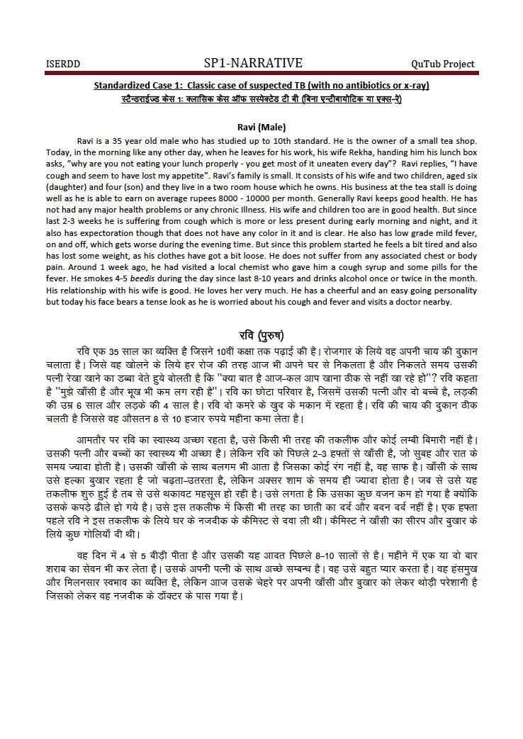

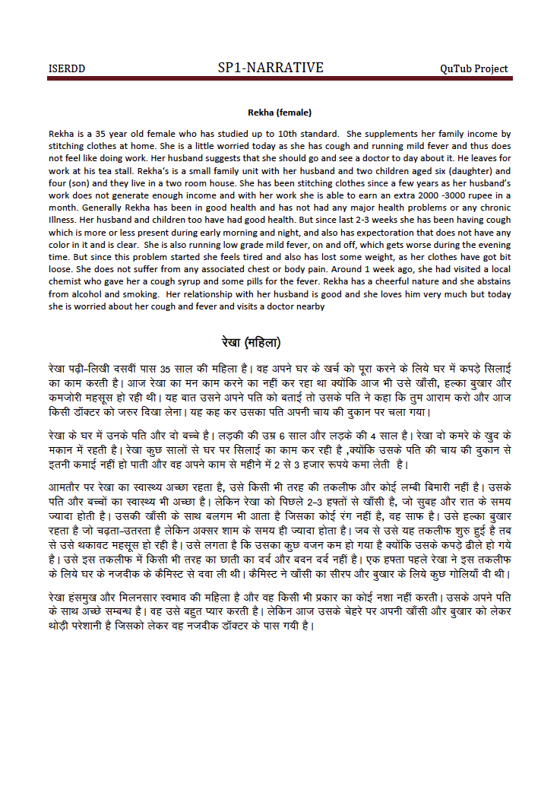

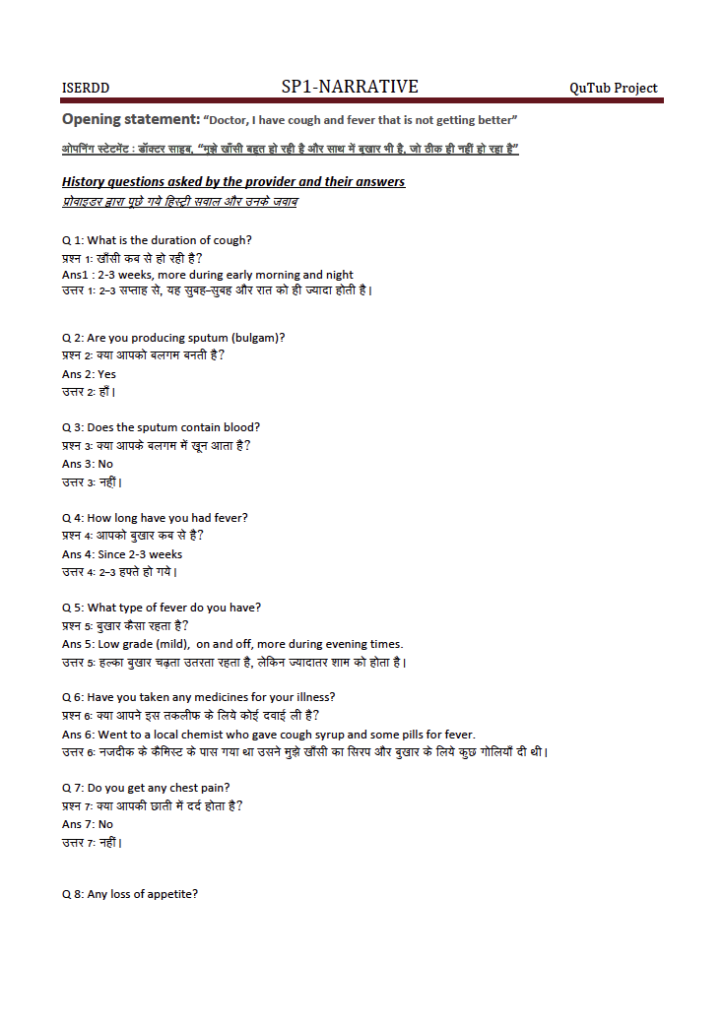

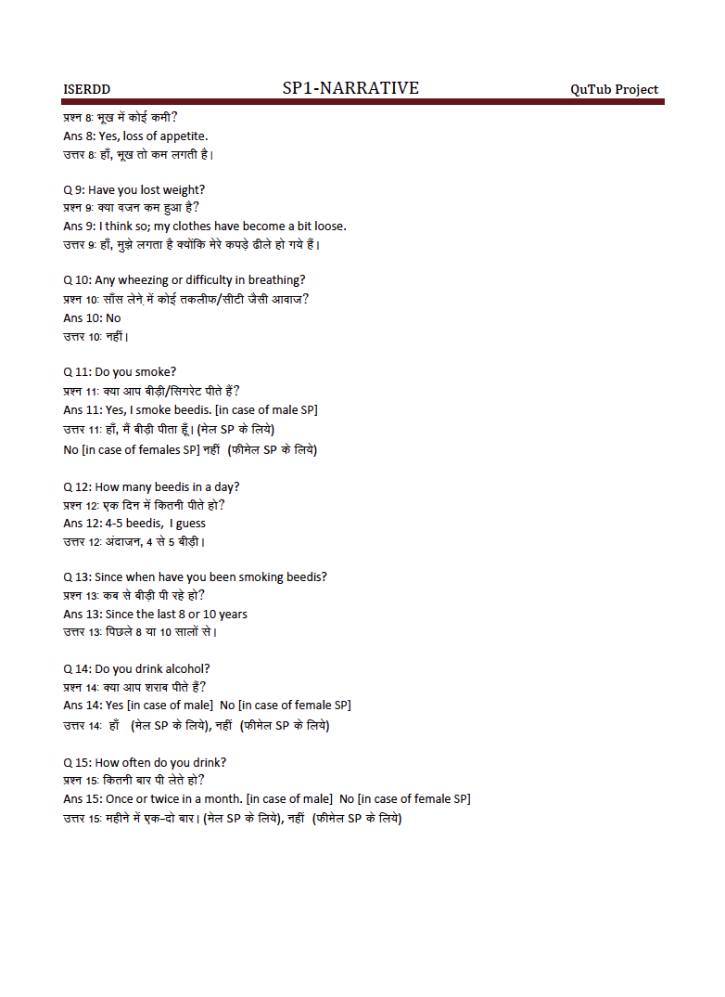

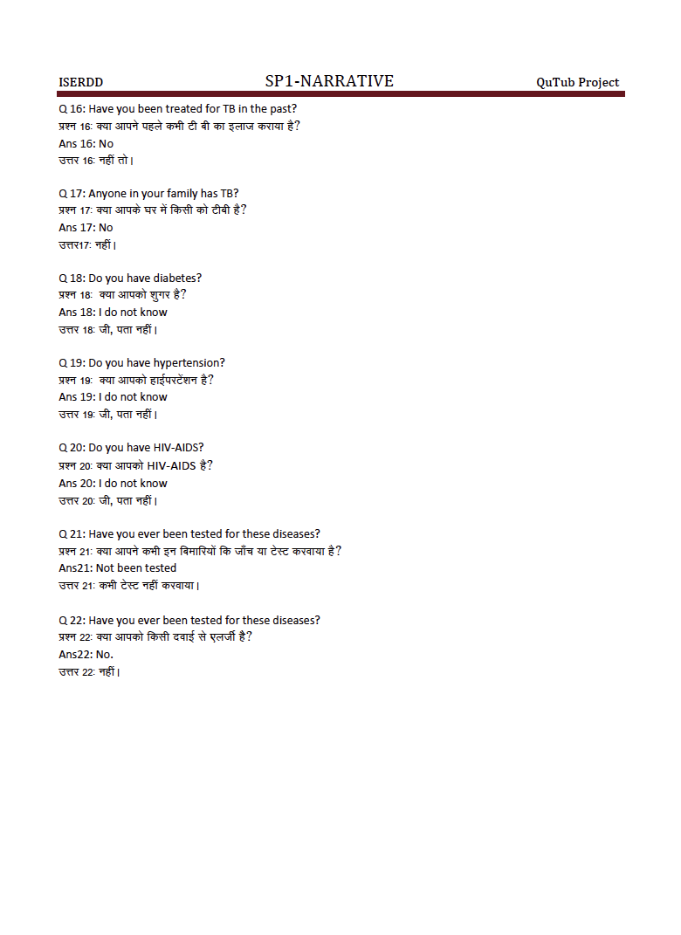

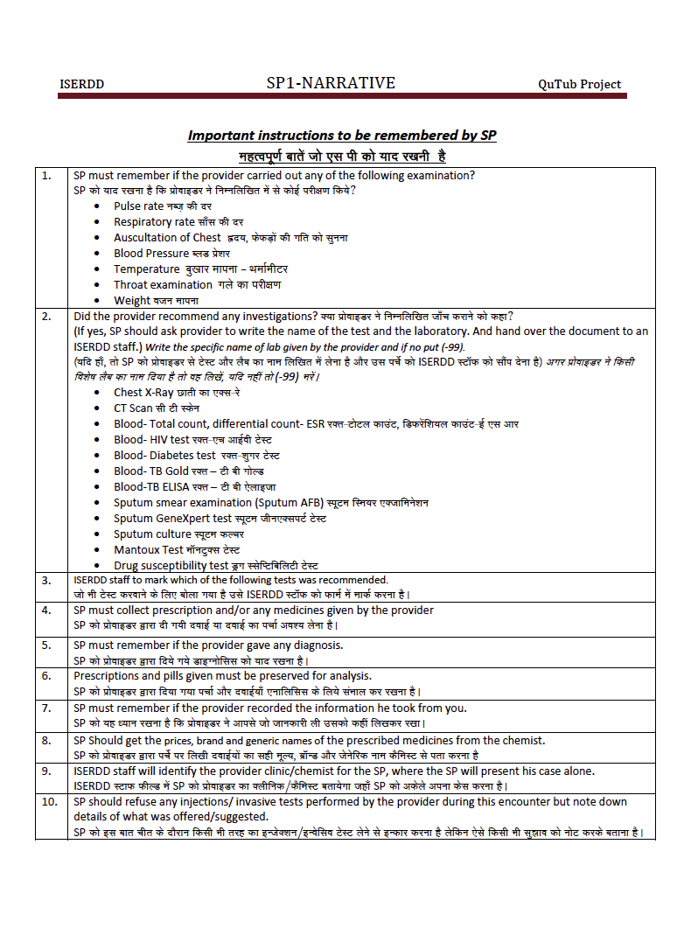

# Annex K. SP exit questionnaire – sample from Qutub Project (Sections 6.2, 6.5)

Source: Qutub project pilot in Delhi

Notes: 9-page exit interview for male and female classic case of suspected tuberculosis (2-3 week cough and fever)

|  |
| --- |
| ***To use this annex as a whole, or in part, please cite:***   * **Kwan A, Bergkvist S, Daniels B, Das J, Das V, Pai M. Using Standardized Patients to Measure Health Care Quality: A Manual and Toolkit for Projects in Low- and Middle-Income Countries. 2018.** * **Das J, Kwan A, Daniels B, Satyanarayana S, Subbaraman R, Bergkvist S, Das RK, Das V, Pai M. Use of standardised patients to assess quality of tuberculosis care: a pilot, cross-sectional study. The Lancet Infectious Diseases. 2015 Nov 30;15(11):1305-13.** |

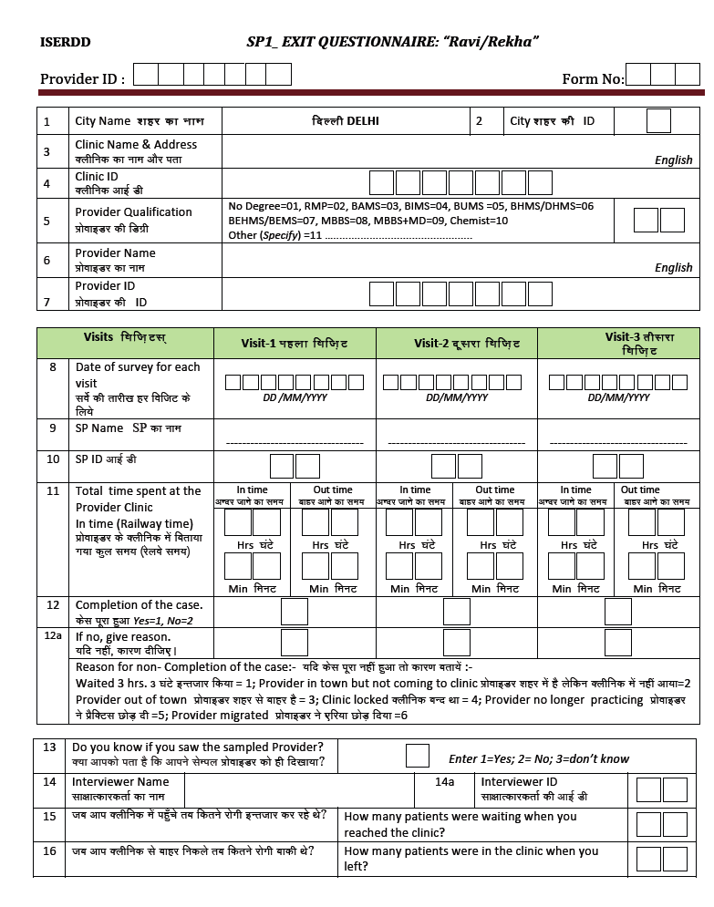

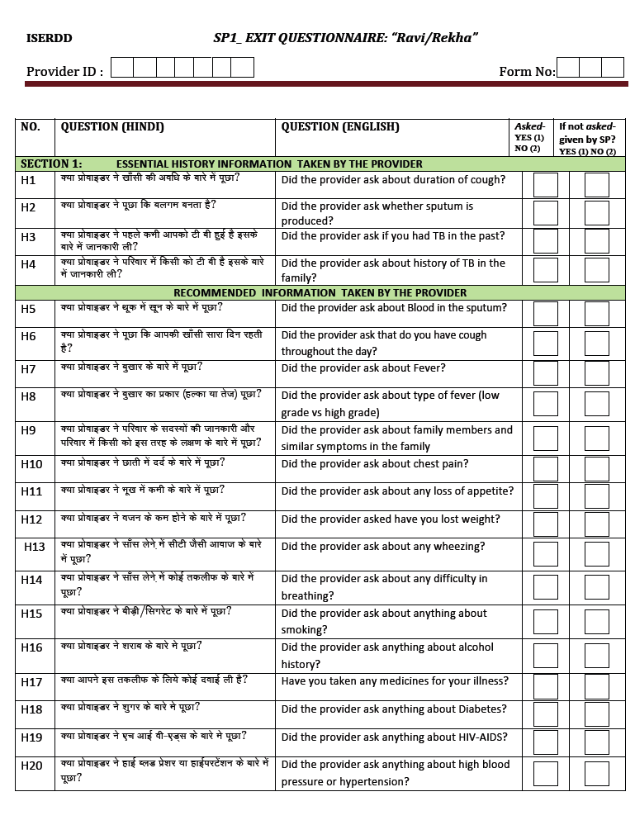

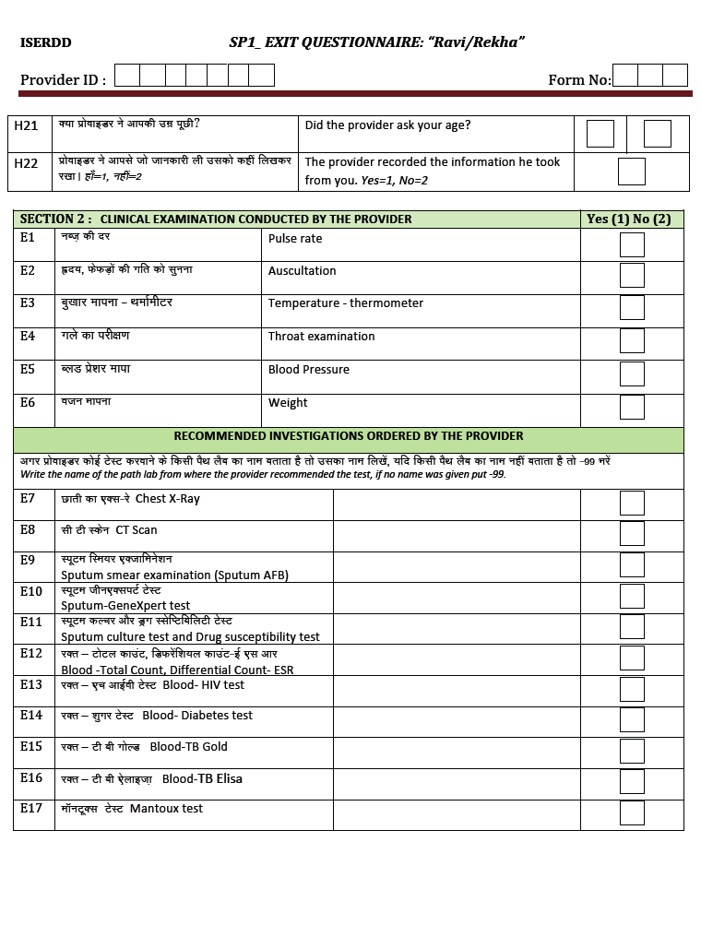

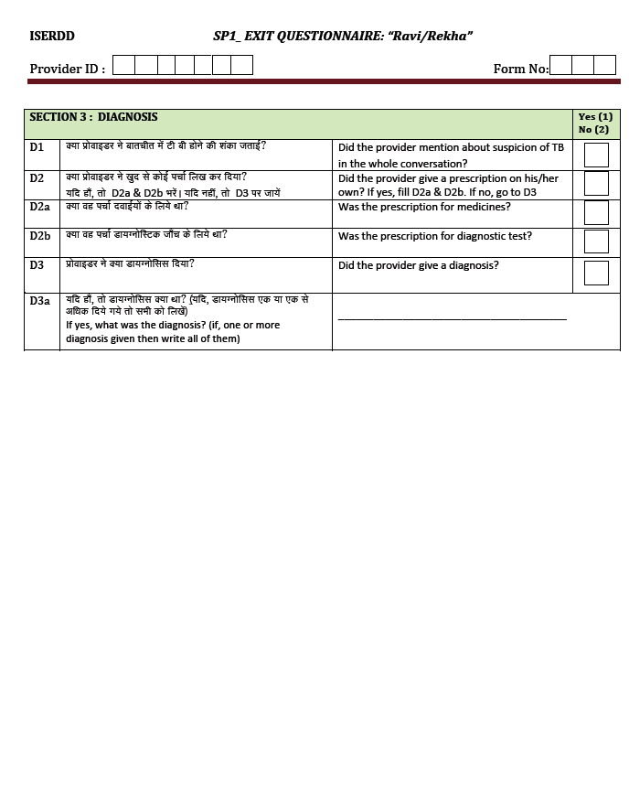

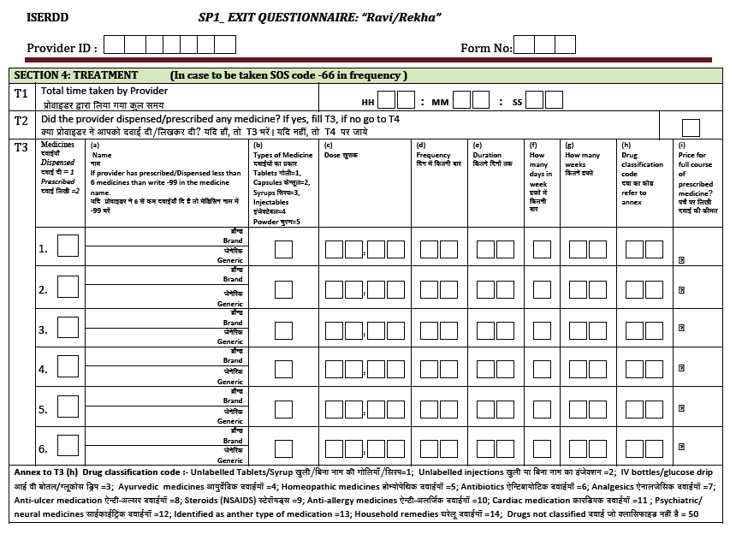

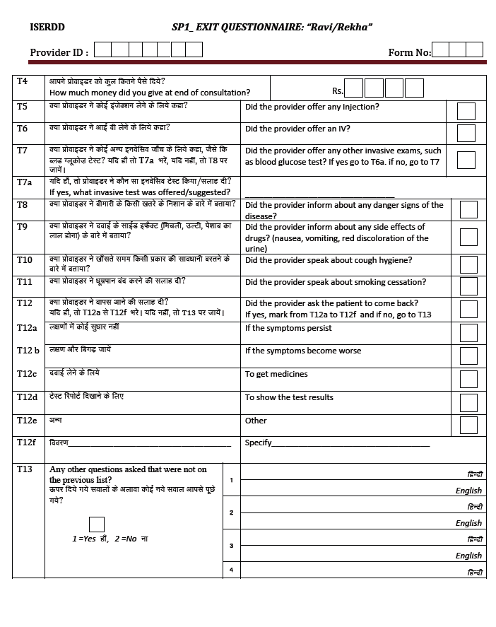

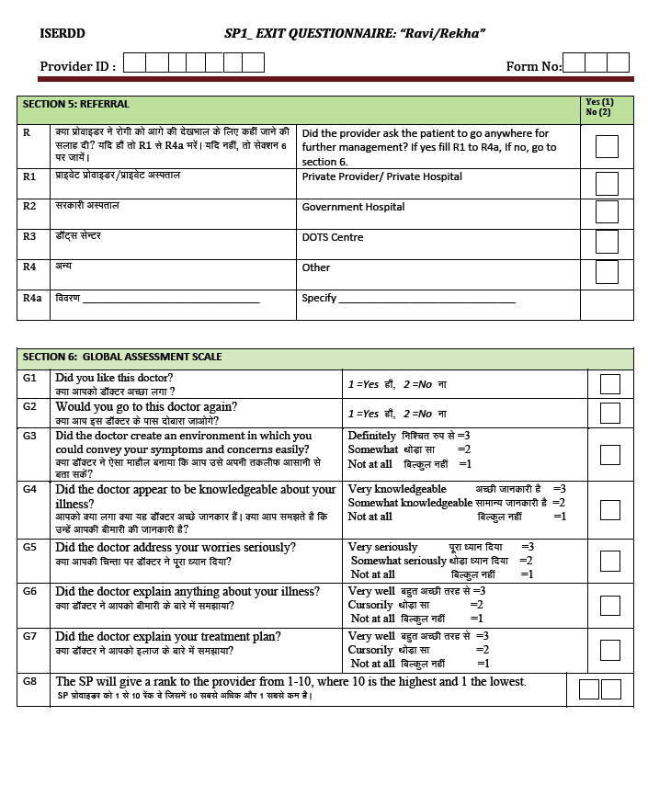

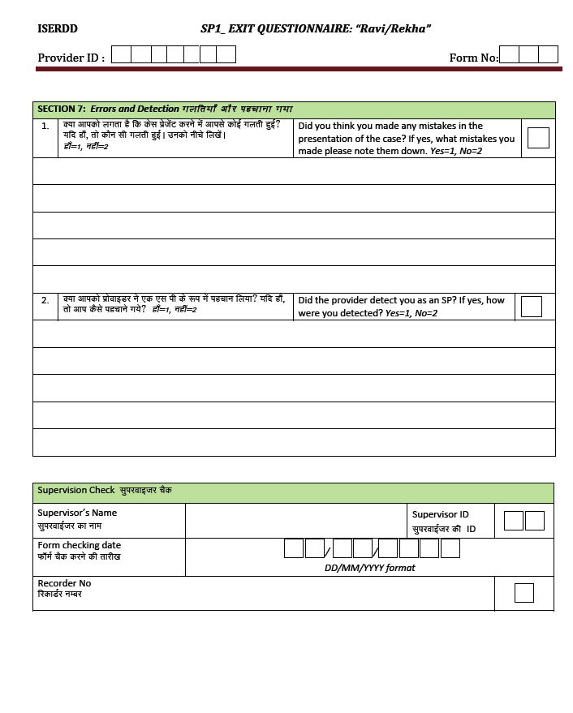

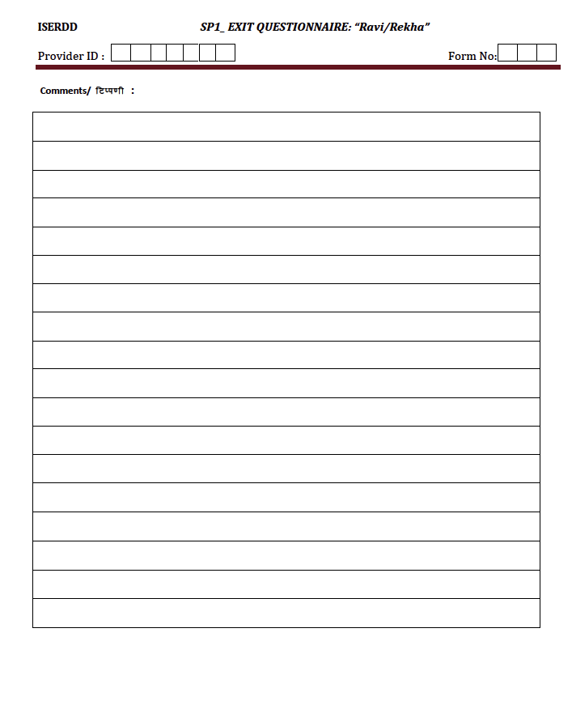

# Annex L. Follow-up detection survey and vignette – sample from Qutub Project (Sections 6.6, 6.7)

Source: Qutub project pilot in Delhi

Notes: 19-page follow-up detection survey and vignette corresponding to case in Annexes F and G (male and female classic case of suspected tuberculosis with 2-3 week cough and fever)

|  |
| --- |
| ***To use this annex as a whole, or in part, please cite:***   * **Kwan A, Bergkvist S, Daniels B, Das J, Das V, Pai M. Using Standardized Patients to Measure Health Care Quality: A Manual and Toolkit for Projects in Low- and Middle-Income Countries. 2018.** * **Das J, Kwan A, Daniels B, Satyanarayana S, Subbaraman R, Bergkvist S, Das RK, Das V, Pai M. Use of standardised patients to assess quality of tuberculosis care: a pilot, cross-sectional study. The Lancet Infectious Diseases. 2015 Nov 30;15(11):1305-13.** |

# Macintosh HD:Users:adakwan:Desktop:Screen Shot 2017-09-23 at 8.08.07 PM.png

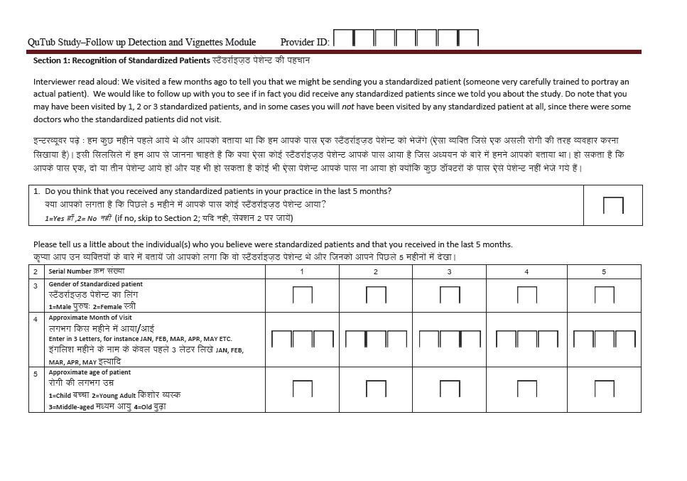

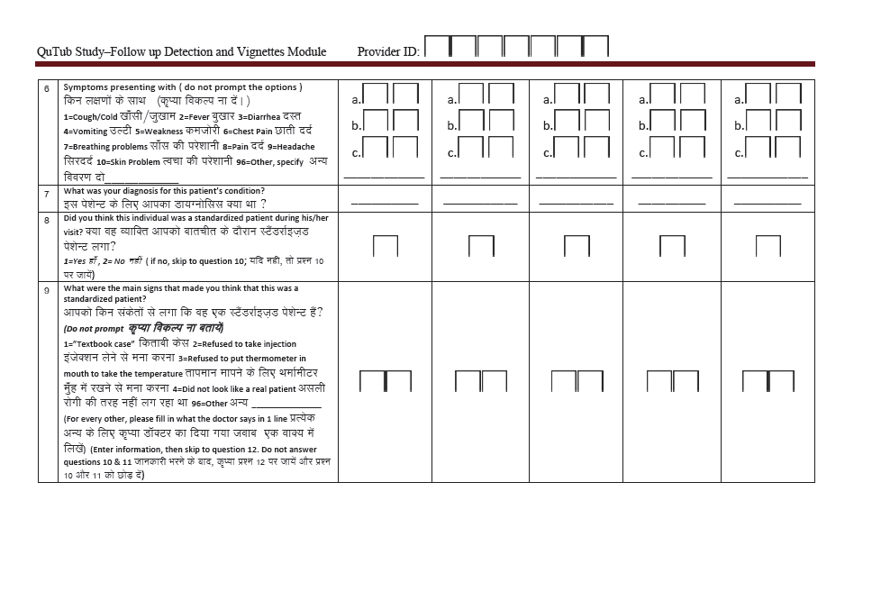

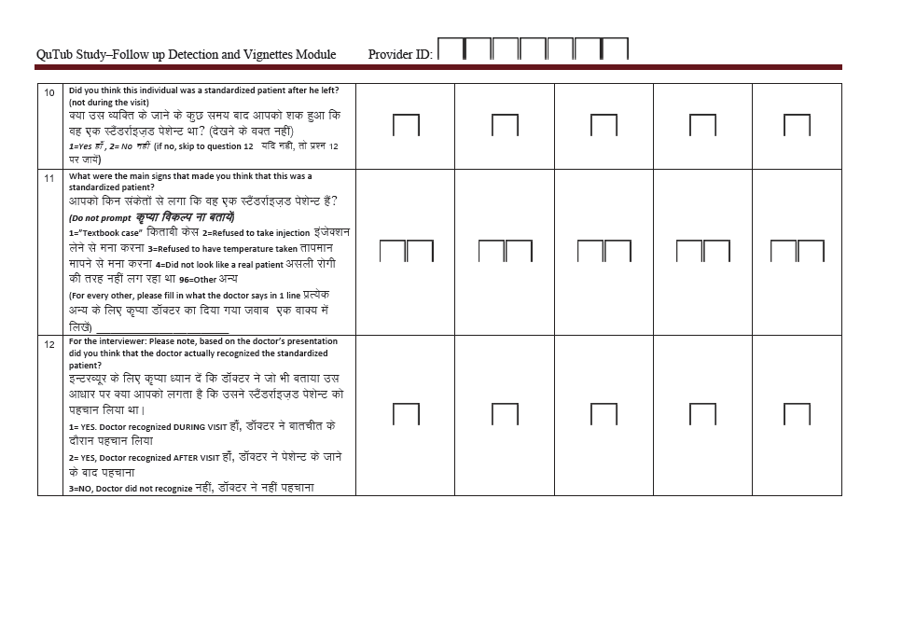

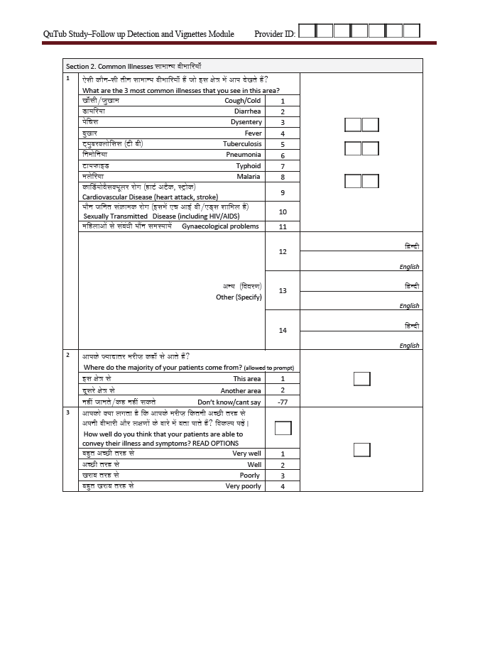

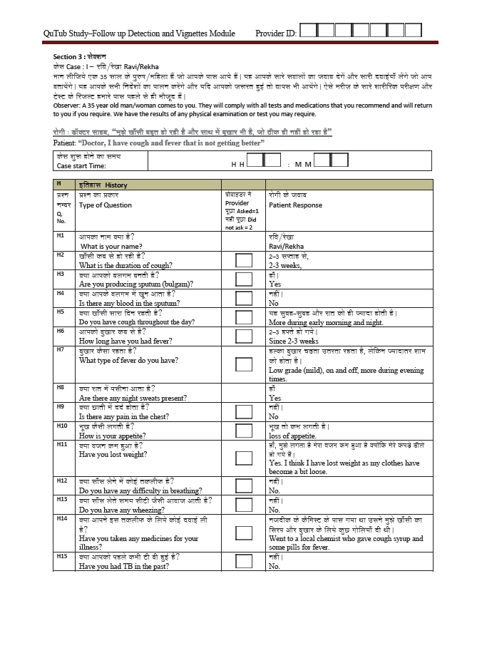

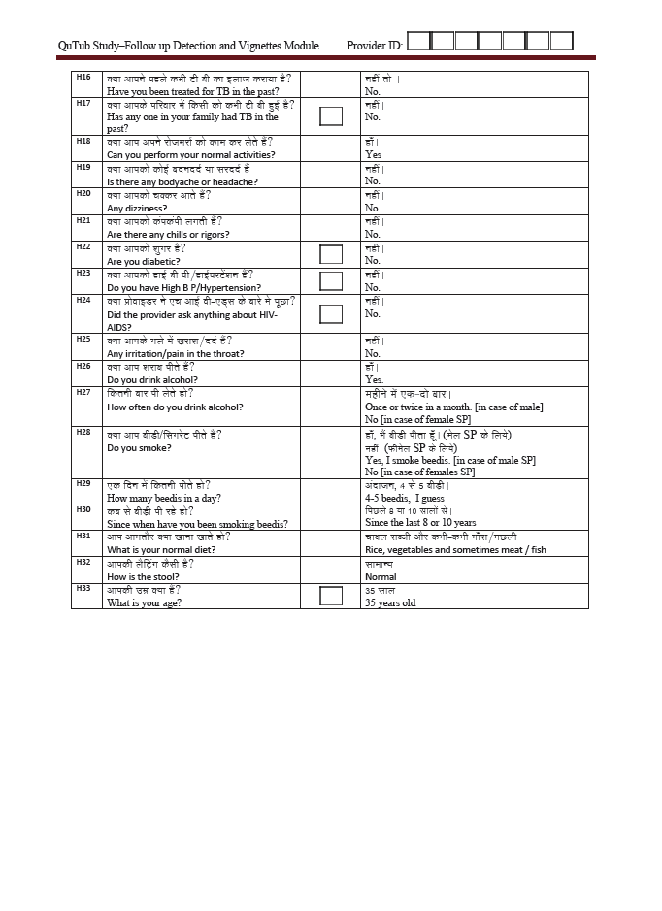

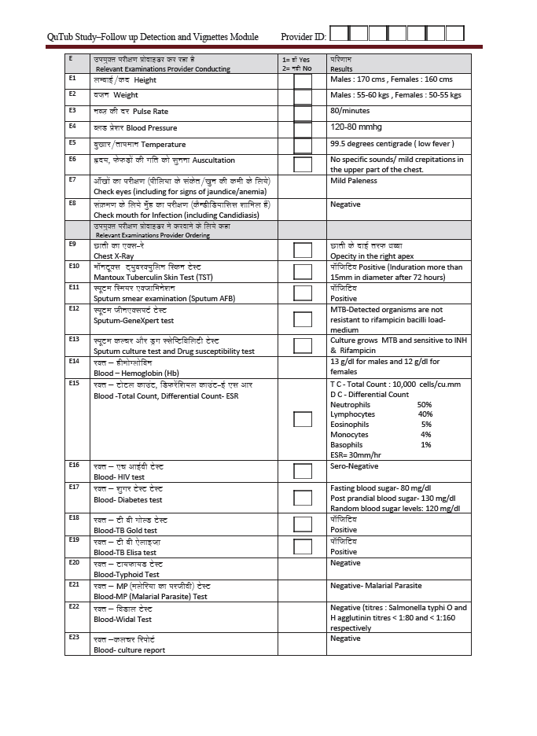

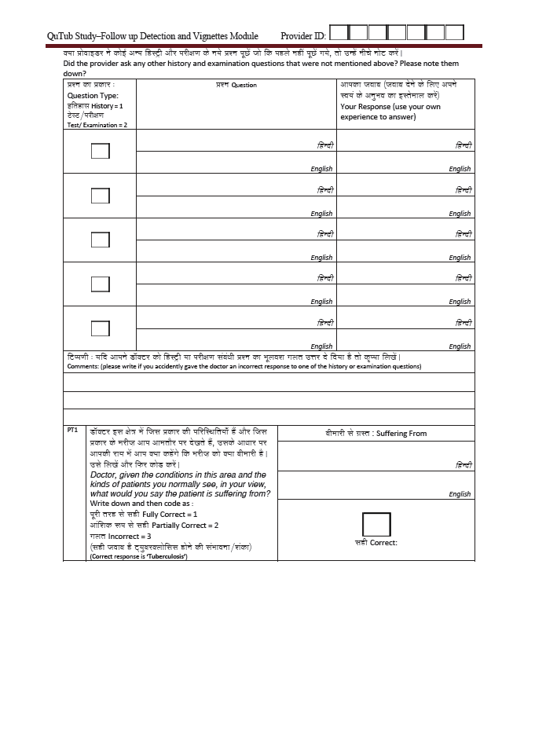

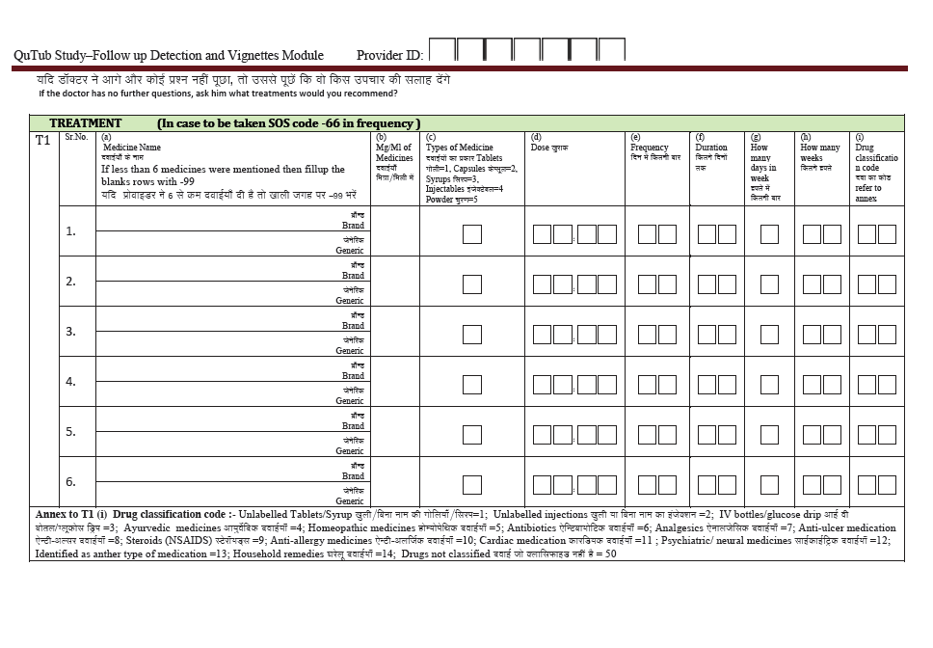

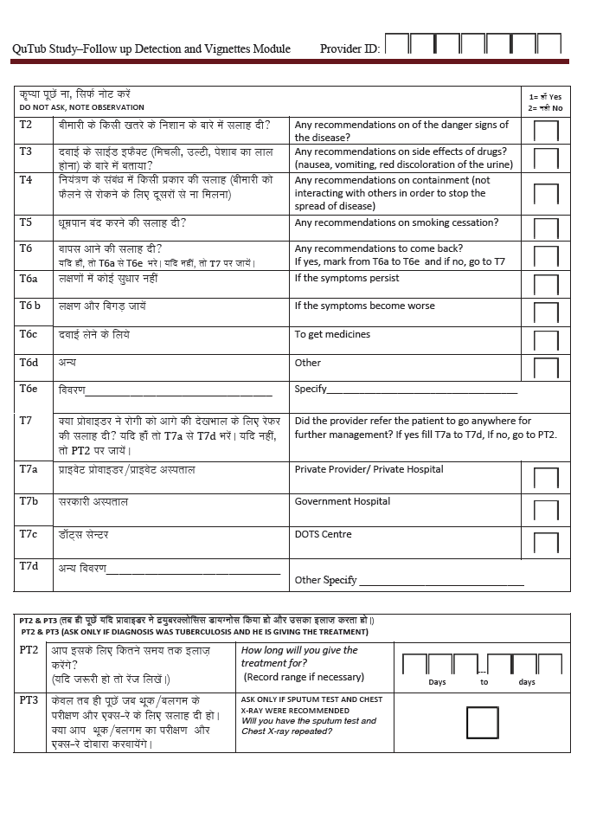

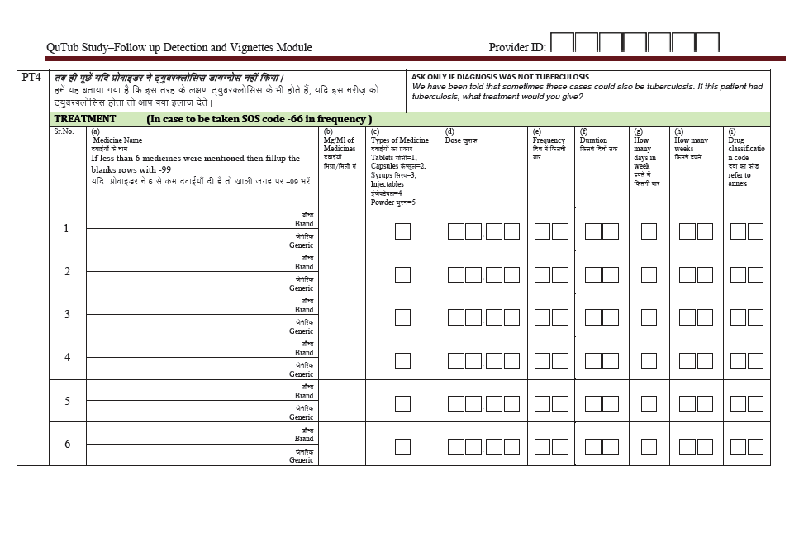

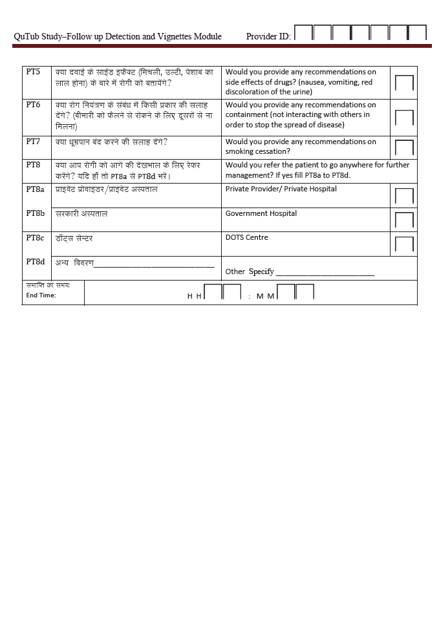

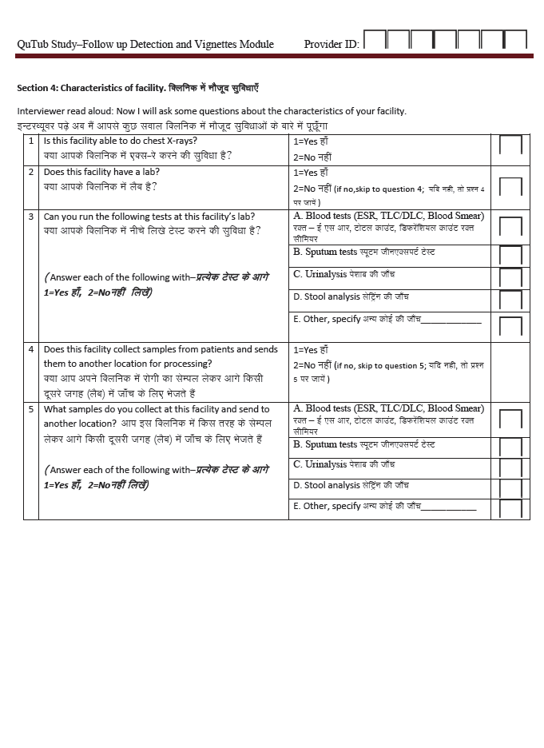

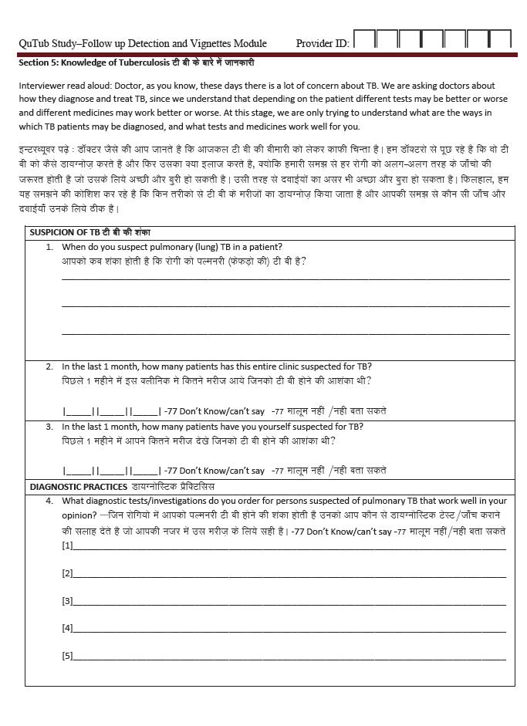

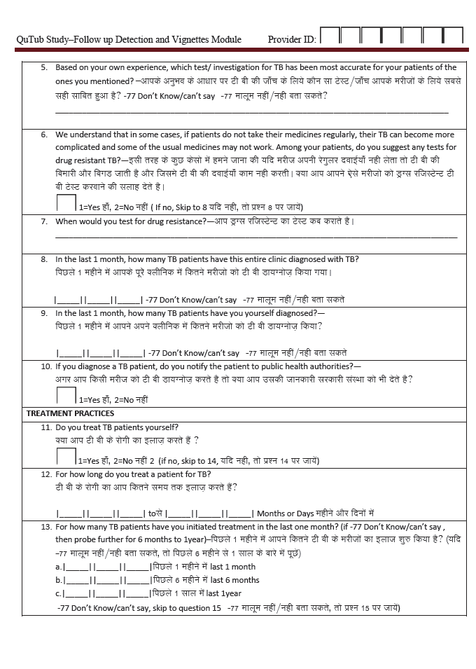

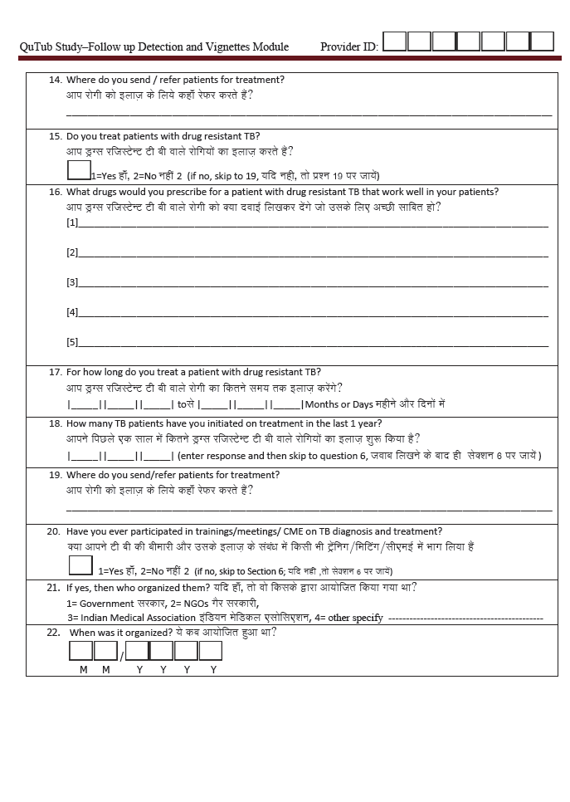

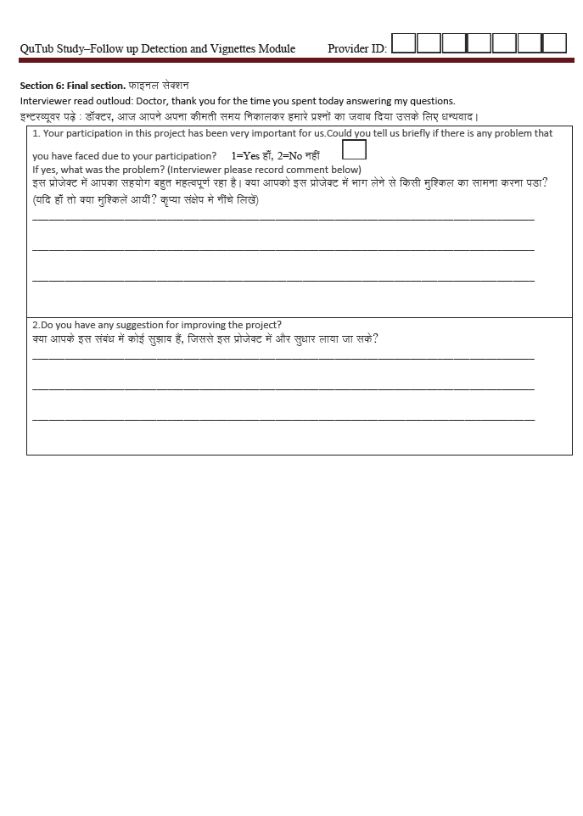

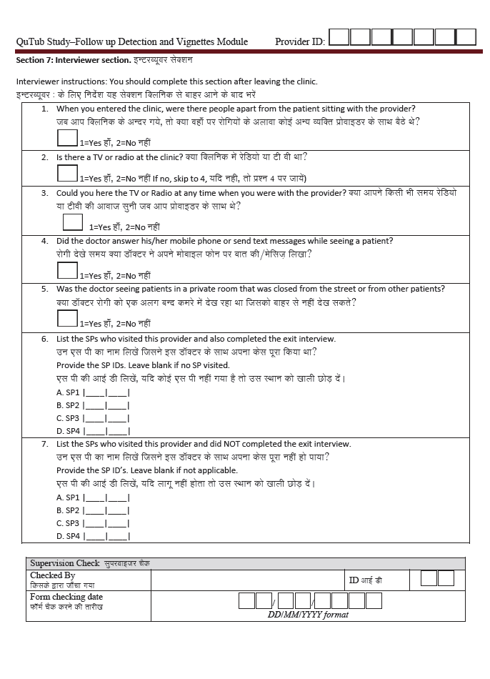

# Annex M. 3-week SP training schedule

|  |
| --- |
| ***To use this annex as a whole, or in part, please cite:***   * **Kwan A, Bergkvist S, Daniels B, Das J, Das V, Pai M. Using Standardized Patients to Measure Health Care Quality: A Manual and Toolkit for Projects in Low- and Middle-Income Countries. 2018.** * **Daniels B, Dolinger A, Bedoya G, Rogo K, Goicoechea A, Coarasa J, Wafula F, Mwaura N, Kimeu R, Das J. Use of standardised patients to assess quality of healthcare in Nairobi, Kenya: a pilot, cross-sectional study with international comparisons. BMJ global health. 2017 Jun 1;2(2):e000333.** |

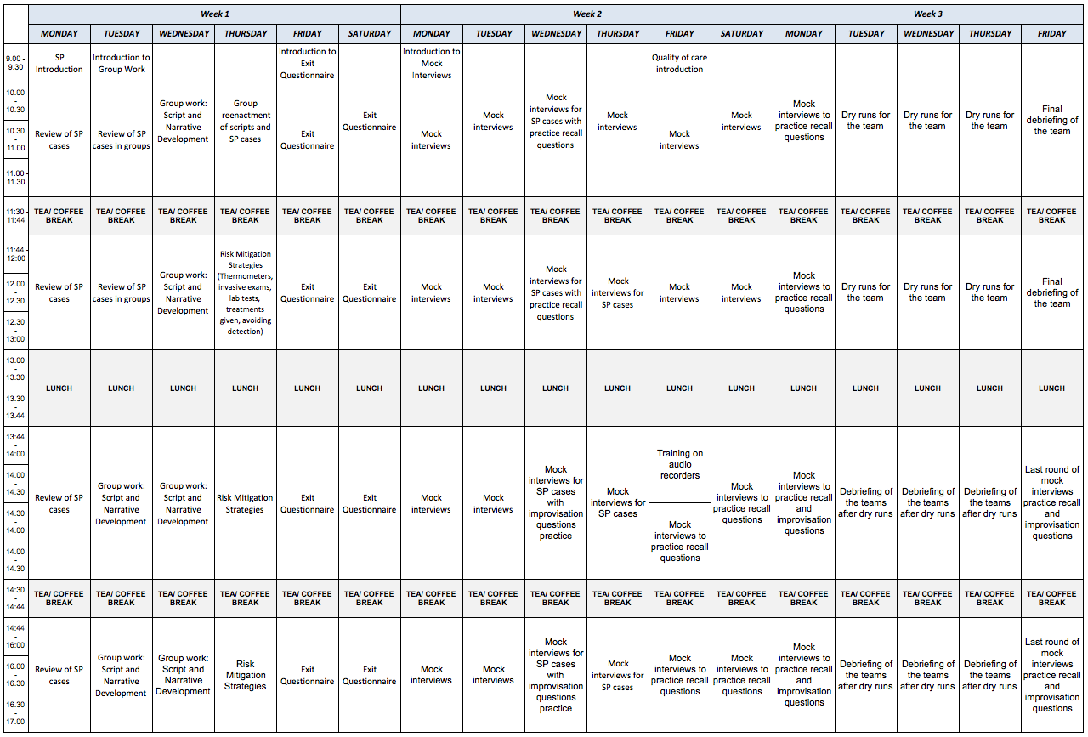

# Annex N. Supervisor fieldwork schedule – Example (Section 9.2)

|  |
| --- |
| ***To use this annex as a whole, or in part, please cite:***   * **Kwan A, Bergkvist S, Daniels B, Das J, Das V, Pai M. Using Standardized Patients to Measure Health Care Quality: A Manual and Toolkit for Projects in Low- and Middle-Income Countries. 2018.** * **Daniels B, Dolinger A, Bedoya G, Rogo K, Goicoechea A, Coarasa J, Wafula F, Mwaura N, Kimeu R, Das J. Use of standardised patients to assess quality of healthcare in Nairobi, Kenya: a pilot, cross-sectional study with international comparisons. BMJ global health. 2017 Jun 1;2(2):e000333.** |

|  |  |  |  |  |  |  |  |
| --- | --- | --- | --- | --- | --- | --- | --- |
| **SP FIELDWORK SCHEDULE** | |  |  |  |  |  |  |
| SPID: |\_\_\_\_|\_\_\_\_| | |  |  |  |  |  |  |
| SP Name: \_\_\_\_\_\_\_\_\_\_\_\_\_\_\_\_\_\_\_\_\_\_\_\_\_\_\_\_\_\_\_ | | |  |  |  |  |  |
|  | *SUNDAY* | *MONDAY* | *TUESDAY* | *WEDNESDAY* | *THURSDAY* | *FRIDAY* | *SATURDAY* |
| MORNING | 1 | 2 | 3 | (DAY 1) 4 | (DAY 2) 5 | (DAY 3) 6 | (DAY 4) 7 |
| Arrival time: | Arrival time: | Arrival time: | Arrival time: | Arrival time: |
| Wait time: | Wait time: | Wait time: | Wait time: | Wait time: |
|  |  |  |  |  |
| Facility name: | Facility name: | Facility name: | Facility name: | Facility name: |
|  |  |  |  |  |
|  |  |  |  |  |
| Facility location: | Facility location: | Facility location: | Facility location: | Facility location: |
|  |  |  |  |  |
|  |  |  |  |  |
| Supervisor and Mobile: | Supervisor and Mobile: | Supervisor and Mobile: | Supervisor and Mobile: | Supervisor and Mobile: |
|  |  |  |  |  |
|  |  |  |  |  |
| AFTERNOON/EVENING |  |  | Arrival time: | Arrival time: | Arrival time: | Arrival time: | Arrival time: |
| Wait time: | Wait time: | Wait time: | Wait time: | Wait time: |
|  |  |  |  |  |
| Facility name: | Facility name: | Facility name: | Facility name: | Facility name: |
|  |  |  |  |  |
|  |  |  |  |  |
| Facility location: | Facility location: | Facility location: | Facility location: | Facility location: |
|  |  |  |  |  |
|  |  |  |  |  |
| Supervisor and Mobile: | Supervisor and Mobile: | Supervisor and Mobile: | Supervisor and Mobile: | Supervisor and Mobile: |
|  |  |  |  |  |
|  |  |  |  |  |
| MORNING | 8 | (DAY 5) 9 | (DAY 6) 10 | (DAY 7) 11 | (DAY 8) 12 | (DAY 9) 13 | (DAY 10) 14 |
| Arrival time: | Arrival time: | Arrival time: | Arrival time: | Arrival time: | Arrival time: | Arrival time: |
| Wait time: | Wait time: | Wait time: | Wait time: | Wait time: | Wait time: | Wait time: |
|  |  |  |  |  |  |  |
| Facility name: | Facility name: | Facility name: | Facility name: | Facility name: | Facility name: | Facility name: |
|  |  |  |  |  |  |  |
|  |  |  |  |  |  |  |
| Facility location: | Facility location: | Facility location: | Facility location: | Facility location: | Facility location: | Facility location: |
|  |  |  |  |  |  |  |
|  |  |  |  |  |  |  |
| Supervisor and Mobile: | Supervisor and Mobile: | Supervisor and Mobile: | Supervisor and Mobile: | Supervisor and Mobile: | Supervisor and Mobile: | Supervisor and Mobile: |
|  |  |  |  |  |  |  |
|  |  |  |  |  |  |  |
| AFTERNOON/EVENING | Arrival time: | Arrival time: | Arrival time: | Arrival time: | Arrival time: | Arrival time: | Arrival time: |
| Wait time: | Wait time: | Wait time: | Wait time: | Wait time: | Wait time: | Wait time: |
|  |  |  |  |  |  |  |
| Facility name: | Facility name: | Facility name: | Facility name: | Facility name: | Facility name: | Facility name: |
|  |  |  |  |  |  |  |
|  |  |  |  |  |  |  |
| Facility location: | Facility location: | Facility location: | Facility location: | Facility location: | Facility location: | Facility location: |
|  |  |  |  |  |  |  |
|  |  |  |  |  |  |  |
| Supervisor and Mobile: | Supervisor and Mobile: | Supervisor and Mobile: | Supervisor and Mobile: | Supervisor and Mobile: | Supervisor and Mobile: | Supervisor and Mobile: |
|  |  |  |  |  |  |  |
|  |  |  |  |  |  |  |
|  |  |  |  |  |  |  |

# Annex O. SP fieldwork schedule – Example (Section 9.2)

|  |
| --- |
| ***To use this annex as a whole, or in part, please cite:***   * **Kwan A, Bergkvist S, Daniels B, Das J, Das V, Pai M. Using Standardized Patients to Measure Health Care Quality: A Manual and Toolkit for Projects in Low- and Middle-Income Countries. 2018.** * **Daniels B, Dolinger A, Bedoya G, Rogo K, Goicoechea A, Coarasa J, Wafula F, Mwaura N, Kimeu R, Das J. Use of standardised patients to assess quality of healthcare in Nairobi, Kenya: a pilot, cross-sectional study with international comparisons. BMJ global health. 2017 Jun 1;2(2):e000333.** |

|  |  |  |  |  |  |  |  |  |  |  |  |
| --- | --- | --- | --- | --- | --- | --- | --- | --- | --- | --- | --- |
| SPID: 11 |  |  |  |  |  |  |  |  |  |  |  |
| SP NAME: \_\_\_\_\_\_\_\_\_\_\_\_\_\_\_\_\_\_\_\_\_\_\_\_\_\_\_\_\_\_ | | | |  |  |  |  |  |  |  |  |
|  |  |  |  |  |  |  |  |  |  |  |  |
|  |  |  |  |  |  |  |  |  |  |  |  |
| FACILITY ID | CASE | SPID | ASSIGNED VISIT 1 DATE DD/MM/YYYY | DAY | SUPERVISOR ID | SUPERVISOR NAME | NAME OF FACILITY | ZONE | FACILITY LOCATION | AVG | BUSIEST DAY OF THE WEEK |
| # OF |
| PATIENTS |
| PER DAY |
| 900001 | SP1 | 11 | 4/9/20XX | 1 | S3 | [NAME S3] | CLINIC 1 | ZONE 1 | LOCATION 1 | 300 | MONDAY |
| 900002 | SP1 | 11 | 4/9/20XX | 1 | S5 | [NAME S5] | CLINIC 2 | ZONE 2 | LOCATION 2 | 3 | UNPREDICTABLE |
| 900003 | SP1 | 11 | 5/9/20XX | 2 | S1 | [NAME S1] | CLINIC 3 | ZONE 3 | LOCATION 3 | 10 | SUNDAY |
| 900004 | SP1 | 11 | 5/9/20XX | 2 | S3 | [NAME S3] | CLINIC 4 | ZONE 4 | LOCATION 4 | 80 | MONDAY |
| 900005 | SP1 | 11 | 6/9/20XX | 3 | S2 | [NAME S2] | CLINIC 5 | ZONE 5 | LOCATION 5 | 120 | MON,WED,FRI |
| 900006 | SP1 | 11 | 6/9/20XX | 3 | S4 | [NAME S4] | CLINIC 6 | ZONE 6 | LOCATION 6 | 16 | MON, TUES |
| 900007 | SP1 | 11 | 7/9/20XX | 4 | S4 | [NAME S4] | CLINIC 7 | ZONE 7 | LOCATION 7 | 22 | MON, SUN |
| 900008 | SP1 | 11 | 7/9/20XX | 4 | S5 | [NAME S5] | CLINIC 8 | ZONE 8 | LOCATION 8 | 10 | MONDAY |
| 900009 | SP1 | 11 | 9/9/20XX | 5 | S4 | [NAME S4] | CLINIC 9 | ZONE 9 | LOCATION 9 | 6 | SATURDAY |
| 900010 | SP1 | 11 | 9/9/20XX | 5 | S5 | [NAME S5] | CLINIC 10 | ZONE 10 | LOCATION 10 | 70 | MONDAY |
| 900011 | SP1 | 11 | 10/9/20XX | 6 | S1 | [NAME S1] | CLINIC 11 | ZONE 11 | LOCATION 11 | 5 | SATURDAY |
| 900012 | SP1 | 11 | 10/9/20XX | 6 | S5 | [NAME S5] | CLINIC 12 | ZONE 12 | LOCATION 12 | 70 | MONDAY |
| 900013 | SP1 | 11 | 11/9/20XX | 7 | S1 | [NAME S1] | CLINIC 13 | ZONE 13 | LOCATION 13 | 100 | MONDAY |
| 900014 | SP1 | 11 | 11/9/20XX | 7 | S5 | [NAME S5] | CLINIC 14 | ZONE 14 | LOCATION 14 |  | SUNDAY |
| 900015 | SP1 | 11 | 12/9/20XX | 8 | S1 | [NAME S1] | CLINIC 15 | ZONE 15 | LOCATION 15 | 20 | NOT SPECIFIC |
| 900016 | SP1 | 11 | 12/9/20XX | 8 | S3 | [NAME S3] | CLINIC 16 | ZONE 16 | LOCATION 16 | 100 | MONDAY |
| 900017 | SP1 | 11 | 13/9/20XX | 9 | S3 | [NAME S3] | CLINIC 17 | ZONE 17 | LOCATION 17 | 10 | MONDAY |
| 900018 | SP1 | 11 | 13/9/20XX | 9 | S5 | [NAME S5] | CLINIC 18 | ZONE 18 | LOCATION 18 | 130 | MONDAY |
| 900019 | SP1 | 11 | 14/9/20XX | 10 | S4 | [NAME S4] | CLINIC 19 | ZONE 19 | LOCATION 19 | 25 | WEDNESDAY |
| 900020 | SP1 | 11 | 14/9/20XX | 10 | S5 | [NAME S5] | CLINIC 20 | ZONE 20 | LOCATION 20 | 20 | WEEKENDS(SATURDAY) |

# Annex P. SP comments – Edited (Section 10.4)

Source: KePSIE project, Kenya

Principal Investigators: Jishnu Das, Guadalupe Bedoya

Project period: 2015 – ongoing

|  |
| --- |
| ***To use this annex as a whole, or in part, please cite:***   * **Kwan A, Bergkvist S, Daniels B, Das J, Das V, Pai M. Using Standardized Patients to Measure Health Care Quality: A Manual and Toolkit for Projects in Low- and Middle-Income Countries. 2018.** * **Daniels B, Dolinger A, Bedoya G, Rogo K, Goicoechea A, Coarasa J, Wafula F, Mwaura N, Kimeu R, Das J. Use of standardised patients to assess quality of healthcare in Nairobi, Kenya: a pilot, cross-sectional study with international comparisons. BMJ global health. 2017 Jun 1;2(2):e000333.** |

|  |  |  |  |
| --- | --- | --- | --- |
| **Health Facility ID** | **SP ID** | **SP Case Type** | **Comments** |
| 9041302 | 43 | Angina | Today I visited a public health facility. I arrived at the facility at 2:23pm and there were 9 patients before me. At the registration, I was not charged anything and they only took my name, age and place of residence. I was attended to by the provider after waiting for 9 minutes. My consultation lasted 2 minutes and 47 seconds. The provider just asked one question and the entry time. He was just writing and never looked at me or even examined me. The facility is well structured but understaffed. The signage is equally poor and finding the various points is difficult. My provider was also busy on phone and he looked like he was in a hurry. There were few clients, mostly expectant and breastfeeding mothers. |
| 9062304 | 43 | Angina | Today I visited a health facility in [LOCATION]. The facility was a private one. When I arrived, there was only one patient being attended to. I arrived at the facility around 10:35am and was immediately attended to by the receptionist who took my name, age, and place of residence. I was ushered into the doctor's room at 10:45am and my consultation lasted 7 minutes. The provider was not in a hurry since there were very few patients. He left me in the consultation room at some point and returned after a minute. He did front auscultation only and asked me if I was coughing the time I usually wake up, if I smoke and the nature of the pain. He did a diagnosis and told me that I had pneumonia and he wanted to inject me there and then, then I would come back for two others. I declined to be injected by telling him that I do my own business and I was alone at my stall so I needed to close it up. He had stated to me that I could pay by installments so the issue of not having money did not apply. |
| 9041303 | 31 | Asthma | The provider told me to avoid allergens cats, dogs, dust, carpets. The provider was very concerned and even wanted to do the test even if I had no money. The provider did not want to give a diagnosis until he is done with the test. The provider explained to me what happens to the airways when one is exposed to the allergens. He explained very well what a full hemogram is. He wanted to do the test there and then but I said that I had no money but will come back in the afternoon. Said he will give me all antibiotics after the test. |
| 9031203 | 13 | Diarrhea | I entered the facility at 12:30pm and left at 12:36pm. There were no other patients in the facility. The provider was very understanding and showed that she was really worried about the baby. She asked me the age, duration, frequency, fever and vomiting. She then said that even though she was really sorry about my baby she couldn't give me any medicine because the baby has to be examined first before being given any medicine. She tried to explain to me more about diarrhea and said that if a child has diarrhea, it should be taken very seriously because she loses a lot of water and it is very risky. She also said that the child should be given a lot of fluids and ORS. If I am able to, I should bring her back to that facility but if I can't manage to bring her back to her, I should take her to the nearest clinic. Generally I liked her. She didn't even ask for any money from me. To me that means she's not after money. |
| 9062306 | 13 | Diarrhea | I entered the facility at 14:20 and left at 15:25. I spent 5 minutes with the doctor. He tried to explain to me that for a child to have diarrhea 6-7 times a night, the child needs to be seen by a doctor. He also said that he cannot give me any medicine because he doesn't know how the baby is right now. That he must see the child first to know what to do. He also said that there might be need for admission of the baby so he has to see the baby first before he can start any treatment. He advised me to take ORS and go and give it to the baby first when I am still preparing to take her to the hospital. He said that being that it's late I should just take her to the nearest health center when I return home. Generally he seemed knowledgeable and tried to explain everything well. I liked him as a provider and I would go back to that health center if at all I am sick or if my baby is sick |
| 9012205 | 11 | Diarrhea | The lady nurse was very interested in knowing more about the child and she did ask me to come with the child for her to run more tests as she had a lab. She was the only person at the health facility operating as the receptionist, consultant as well as the pharmacist. The environment at the clinic was very clean and it was not that busy. She was able to explain to me more about the child's health and she was much more concerned about my worries and advised me to bring the child for a check up. She told me to give the child a lot of boiled water. She asked me to give the child ORS mixed with boiled water (500ml). |
| 9012207 | 11 | Diarrhea | The health provider gave me all the time and explained to me how dangerous it is for a child to have watery diarrhea. He was also able to educate me on how to prepare the ORS and how to give to the child through the day and night. He also told me about how to mix the zinc, advantages of the zinc and how it helps the child. I was given three options: (i) Mix with little breast milk. (ii) Mix with little ORC. (iii) Mix with little boiled water. He also told me to make sure that everything that I use to store water is clean and the water must be boiled. The facility is small and they have many patients to be seen. He also told me to go home and take care of my child. |
| 9061301 | 12 | Diarrhea | I went to the facility at 9:40am. Waited for 20 minutes. After registering, I went to the triage and insisted that I wanted to see the provider. They allowed me. I went to give my complaint to the provider. She asked me the age, frequency, and duration. She asked me where I live. I told her [LOCATION OF HOME]. She advised me to go back home, come with the child because it was good the child to be checked for temperature and weight. The stool should be investigated to find the cause of diarrhea. She told me to leave the facility immediately and bring the child. I left the facility at 10:09 am |
| 9062201 | 24 | TB | The facility is a private one and consists of three rooms: waiting bay, pharmacy and consultation room, which also doubles as a triage. There were no patients in the waiting bay when I arrived and the health service provider ushered me to the consultation room where he went directly into asking me what was wrong with me. No demographics was taken at this stage. After questioning me for a few minutes and carrying out auscultation, he went on to explain that I could be suffering from TB, but he could not rule out brucellosis. He then proceeded to explain me in detail the clinical manifestations of both diseases and their treatment courses. Finally he dispensed some drugs, which he said would probably cure the condition and asked me to go back in the evening to receive the first of my three injections. In the event that this treatment course failed, he was to follow it up with the sputum test and chest X-ray to ascertain whether I could be suffering from TB. He also asked me whether I was married and what was my occupation. Additionally, he carried out a clinical exam that I have never heard of which involved placing the index finger between two of my ribs and tapping the finger all this while listening for any unusual sounds. The last thing he asked me was my name from then on. He switched on to local [DIALECT] as he put the dispensed drugs in a black paper bag. |
| 9062204 | 24 | TB | The facility is a private one and appears to be managed by only one health service provider. It is partitioned into three rooms - waiting bay (looked more of a corridor), consultation room and a store. The consultation room also served as the pharmacy. The health service provider asked me to take the medication until all is used up except in the case of syrup, which I was supposed to stop taking once I stop coughing. The health service provider asked whether he had seen me before (i.e., in his facility) and when I replied that he hadn't he proceeded to record my name in his register. He didn't ask me how old I was although he remarked that he had never seen me in that area before. Upon noticing that my name was [FROM AN ETHNIC GROUP], he carried on the rest of the consultation in [DIALECT]. In the waiting bay were 9 posters on the wall but only one had a health related message. The rest were "decorations". The syrup dispensed was poured from a jerrycan into a bottle he had just washed in the wash-hand basin. |
| 9062302 | 24 | TB | The facility is a private one and has three separate rooms - the consultation room (which is equipped with an ultra sound machine), waiting bay and the pharmacy. In spite of undertaking general consultations the facility has a [FRANCHISE NAME] clinic, which offers MCH services. In fact out of all the patients I saw in the facility I was the only man and most of the rest had small babies with them. Although the facility was not "roomy" enough the health service provider interacted with went off her way to ensure that she left nothing to chance by referring me to a nearby facility for TB screening. She did not charge me any consultation fees in spite of my asking her what the charges would be. No clinical exams were carried out nor were any drugs prescribed by the health service provider. She said she would only do so after she had ruled out a TB infection after the screening. |
| 9062304 | 22 | TB | I walked into the facility and there was no one waiting. So after registration I walked directly to the consultation room. The provider who was a male and did not have a white coat, just casually dressed, asked the questions in regard to my illness then came in a lab technician who the provider consulted about the symptoms of my illness and that I was required to do a sputum test, which they said that it will be done 3 times and that I should bring the first sample tomorrow morning. Then the lab technician left then the provider recommended that I should be given some antibiotic injections and medicines, then again he recommended for typhoid and another test, which is indicated on the lab request form to be done there and then. I was given two tins labeled 1 and 2. Tin 1 I was to put the sputum any time from now till before bedtime, and tin 2 I was to put the sputum in the morning before doing anything. |
| 9062303 | 21 | TB | When I arrived I found the receptionist watching news on TV. He directed me to a room, which I was to meet the doctor but to my surprise he came to attend to me. There was no registration done to me but asked my problem. He then asked me the duration of the cough and medication I had used previously. Then he did auscultation and told me that I should get three injections one day each. The cost of medication was 1500. I tried to ask for another option like medicines but he told me since I had used medicine previously and it did not work there was no need. He insisted on injection and demanded that I should first pay whatever I have and come with the rest. I told him that I live in the next plot and I only wanted to know my problem and can start medication in the afternoon. He dismissed me on grounds that I should come back in the afternoon with some money. To me this provider did not appear to be a doctor but was just a conman that was interested in my money. |
| 9061301 | 21 | TB | The provider asked me only two questions which is cough duration and if I had been treated. He was not interested to know my condition that had brought me to him but decided to to send me to the lab for a sputum test. The lab tech was interested a bit because she asked me about people I live with and talked about cough hygiene, which I should do to avoid infecting family members with TB. She gave me 2 test tubes to go and collect sputum and then bring back the next day. I did not like the kind of service offered by the provider and I can't go back to him for treatment. I was able to know the provider's name and qualification from the lab form that was given. |

# Annex Q. SP data files (Section 11)

|  |
| --- |
| ***To use this annex (Q1-Q6) as a whole, or in part, please cite:***   * **Kwan A, Bergkvist S, Daniels B, Das J, Das V, Pai M. Using Standardized Patients to Measure Health Care Quality: A Manual and Toolkit for Projects in Low- and Middle-Income Countries. 2018.** * **Das J, Kwan A, Daniels B, Satyanarayana S, Subbaraman R, Bergkvist S, Das RK, Das V, Pai M. Use of standardised patients to assess quality of tuberculosis care: a pilot, cross-sectional study. The Lancet Infectious Diseases. 2015 Nov 30;15(11):1305-13.** |

1. Provider universe master code file
2. Sample master code file
3. Schedule master code file
4. SP staff master code file
5. Medicines master code file
6. Exit questionnaire master data dictionary file

# Annex Q1. SP data files – Provider universe master code example (Section 11.1)

This example file can be accessed at:

*https://www.qutubproject.org*

# Annex Q2. SP data files – Sample master code file example (Section 11.1)

This example file can be accessed at:

*https://www.qutubproject.org*

# Annex Q3. SP data files – Schedule master code file example (Section 11.1)

This example file can be accessed at:

*https://www.qutubproject.org*

# Annex Q4. SP data files – SP staff master code file example (Section 11.1)

This example file can be accessed at: *https://www.qutubproject.org*

**Master supervisor list**

|  |  |  |
| --- | --- | --- |
| **supervisor\_id** | **supervisor\_name** | **supervisor\_gender** |
| 91 |  |  |
| 92 |  |  |
| 93 |  |  |
| 94 |  |  |
| 95 |  |  |
| 96 |  |  |
| 97 |  |  |
| 98 |  |  |
| 99 |  |  |

**Master SP list**

|  |  |  |  |  |  |  |  |  |  |  |
| --- | --- | --- | --- | --- | --- | --- | --- | --- | --- | --- |
| **sp\_id** | **sp\_name** | **case\_id** | **sp\_dob** | **sp\_age\_2016** | **sp\_gender** | **sp\_weight (kios)** | **sp\_height (meters, X.XX)** | **sp\_city (city where sp is from)** | **sp\_state (state where sp is from)** | **sp\_languages** |
| 10 | SP1 default | SP1 |  |  |  |  |  |  |  |  |
| 11 |  |  |  |  |  |  |  |  |  |  |
| 12 |  |  |  |  |  |  |  |  |  |  |
| 13 |  |  |  |  |  |  |  |  |  |  |
| 20 | SP2 default | SP2 |  |  |  |  |  |  |  |  |
| 21 |  |  |  |  |  |  |  |  |  |  |
| 22 |  |  |  |  |  |  |  |  |  |  |
| 23 |  |  |  |  |  |  |  |  |  |  |
| 30 | SP3 default | SP3 |  |  |  |  |  |  |  |  |
| 31 |  |  |  |  |  |  |  |  |  |  |
| 32 |  |  |  |  |  |  |  |  |  |  |
| 33 |  |  |  |  |  |  |  |  |  |  |
| 40 | SP4 default | SP4 |  |  |  |  |  |  |  |  |
| 41 |  |  |  |  |  |  |  |  |  |  |
| 42 |  |  |  |  |  |  |  |  |  |  |
| 43 |  |  |  |  |  |  |  |  |  |  |

# Annex Q5. SP data files – Medicines master code file example (Section 11.1)

This example file can be accessed at:

*https://www.qutubproject.org*

# Annex Q6. SP data files – Exit questionnaire master data dictionary file example (Section 11.3)

This example file can be accessed at:

*https://www.qutubproject.org*